APPLICATION LB PRACTICALS

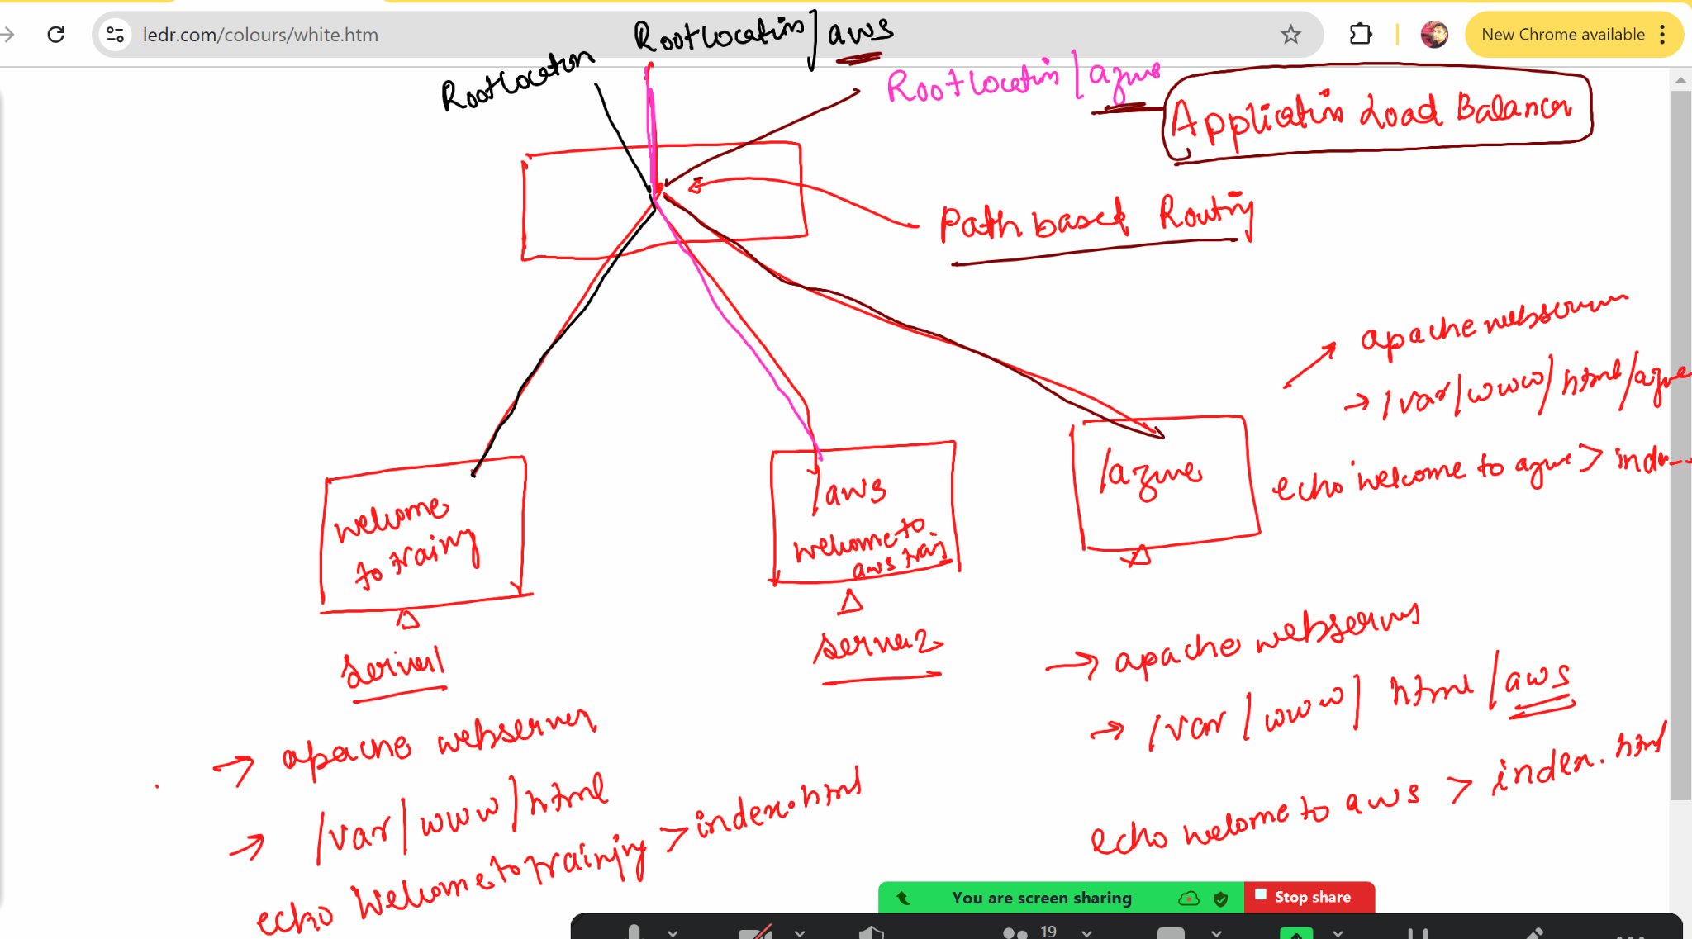

> We will create two security grups one for application load balancer and one for machines

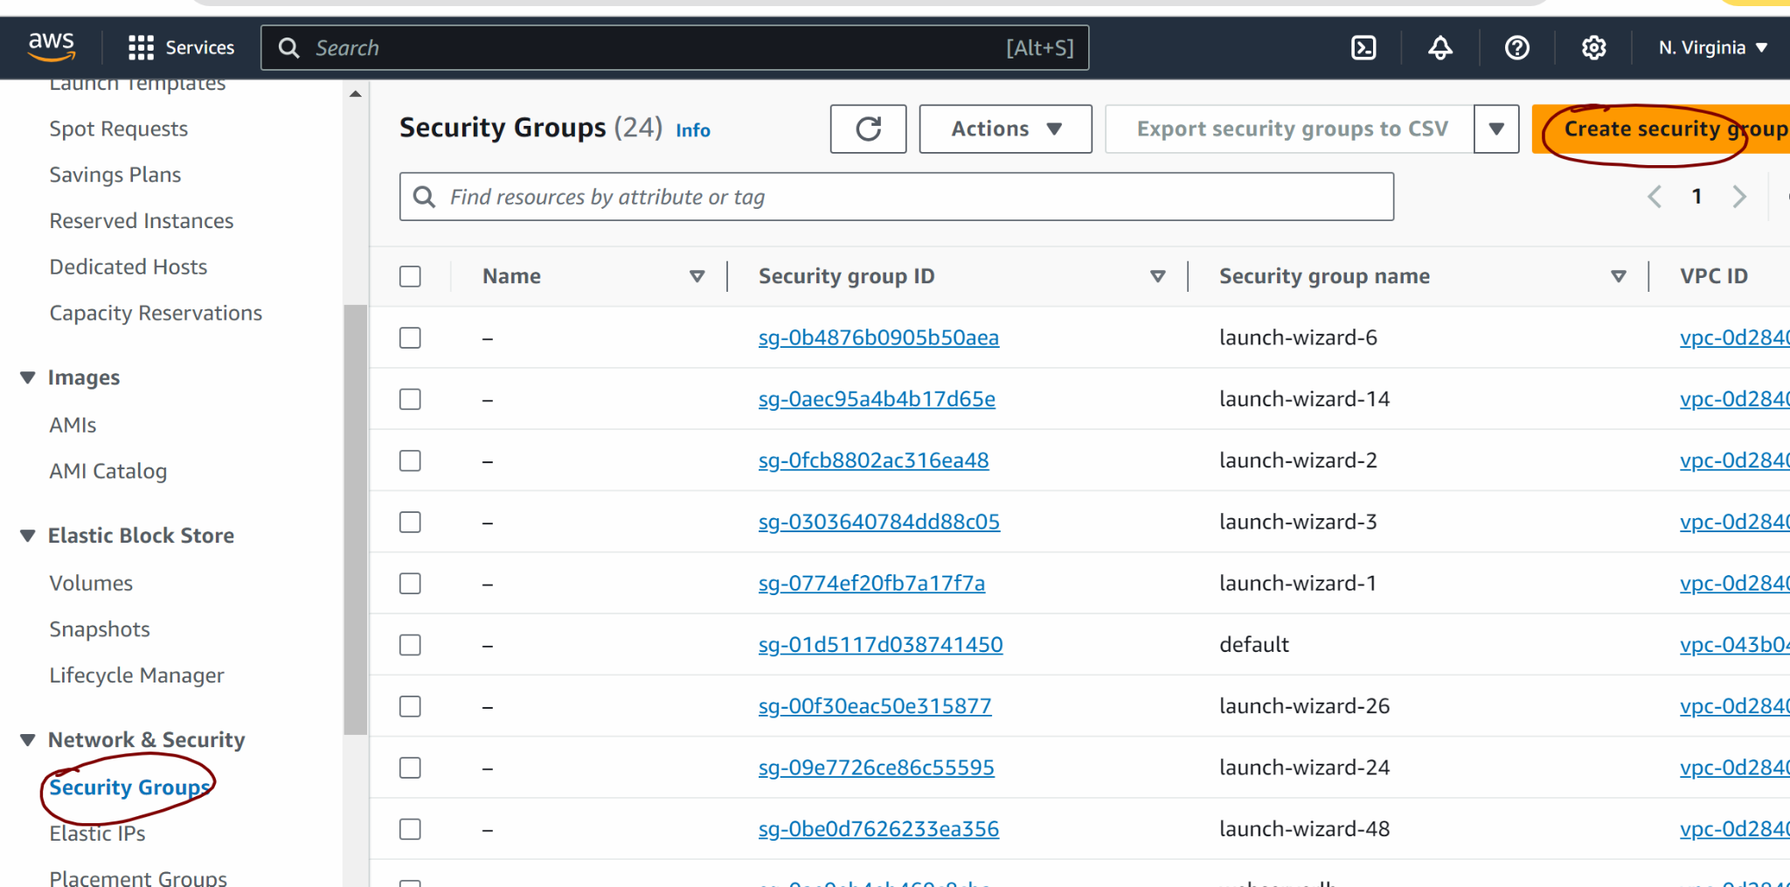

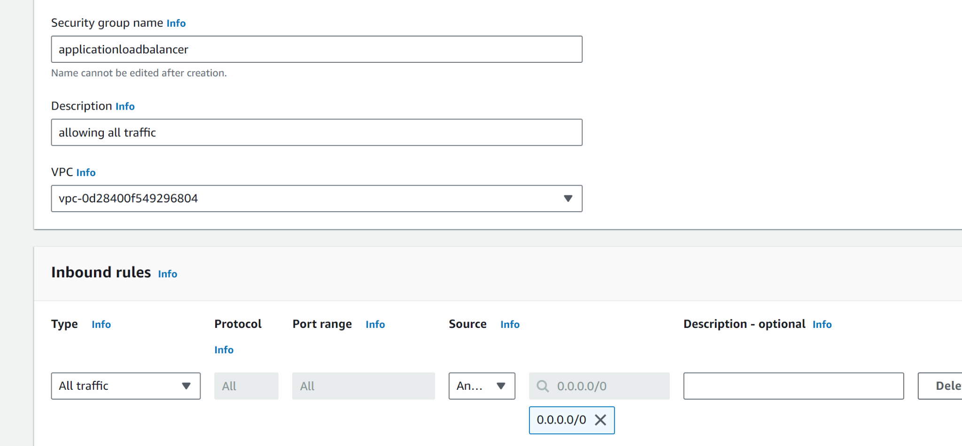

Save

Lets create one more security group

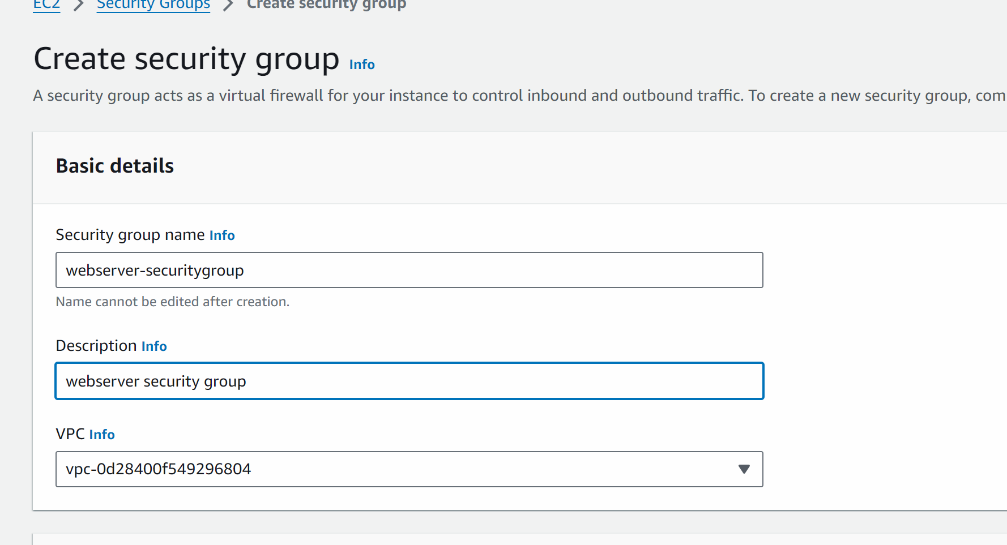

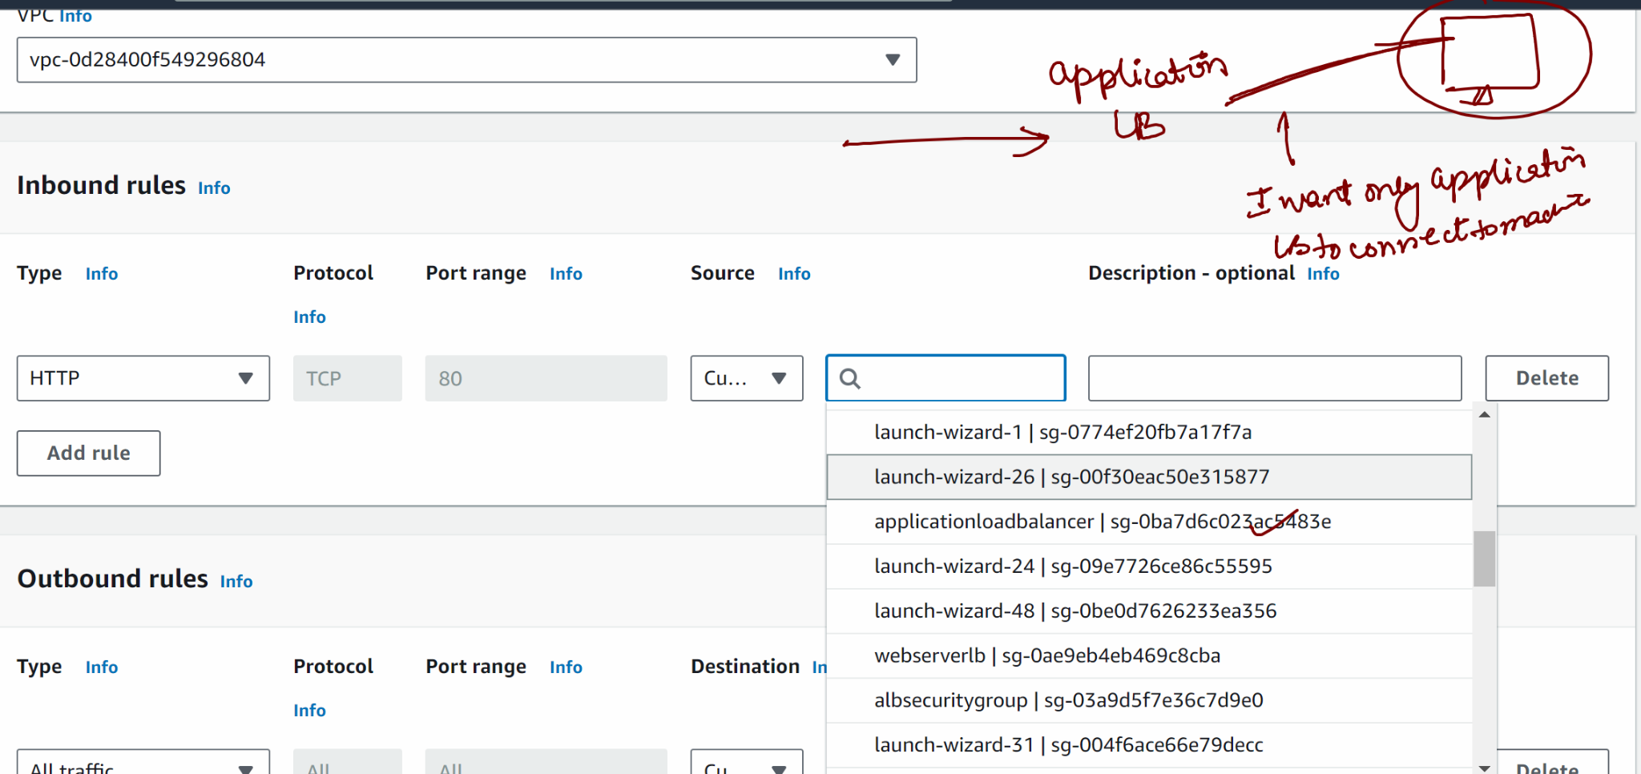

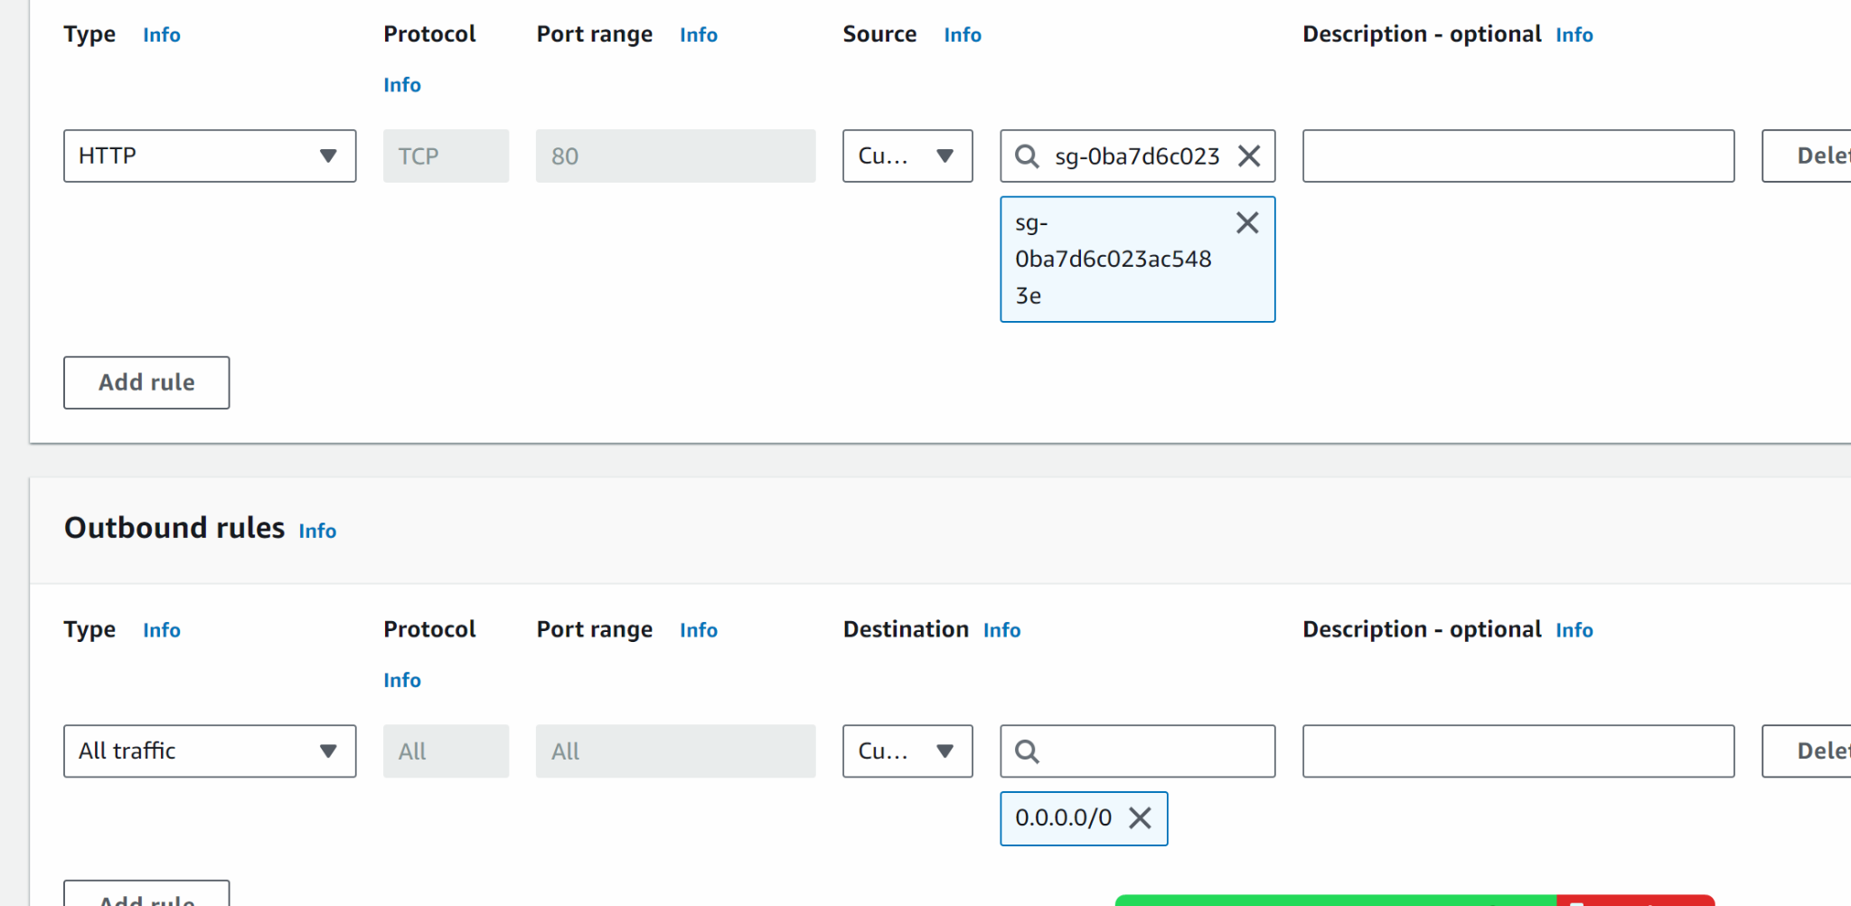

Save

### WE WILL NOW CREATE 3 MACHINES ONE BY ONE (NOT TOGETHER) …
IN FIRST MACHINE WE WILL HOST HELLO WELCOME TO TRAINING IN ROOT LOCATION
IN SECOND MACHINE WE WILL HOST HELLO WELCOME TO AWS IN ROOT/AWS lOCATIOn

IN THIRD MACHINE WE WILL HOST HELLO WELCOME TO AZURE IN ROOT/AZURE LOCATION

LETS CREATE FIRST MACHINE

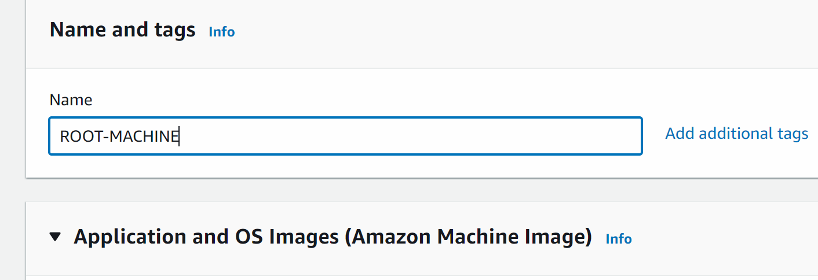

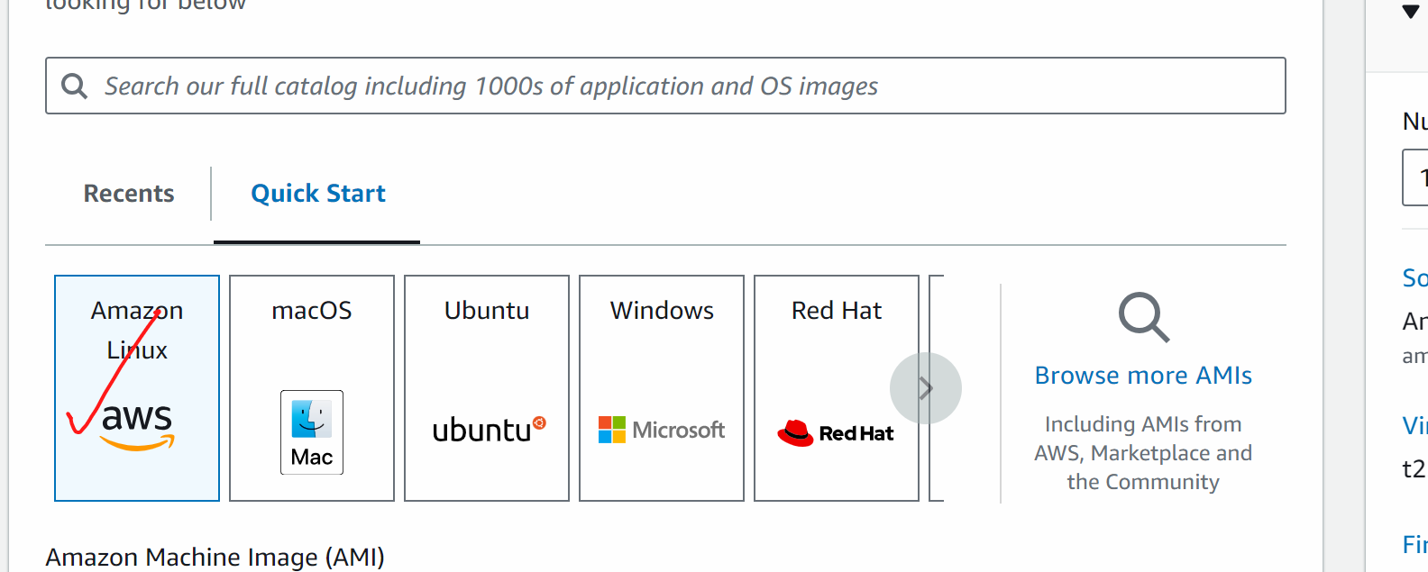

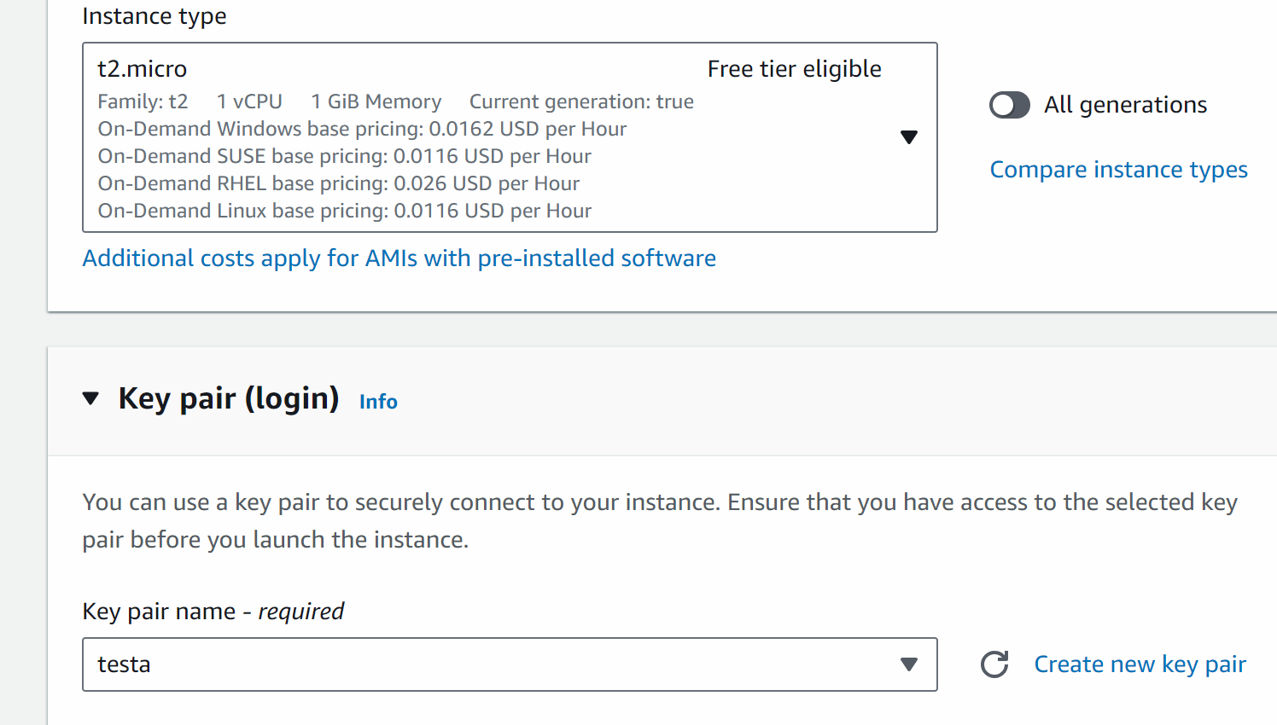

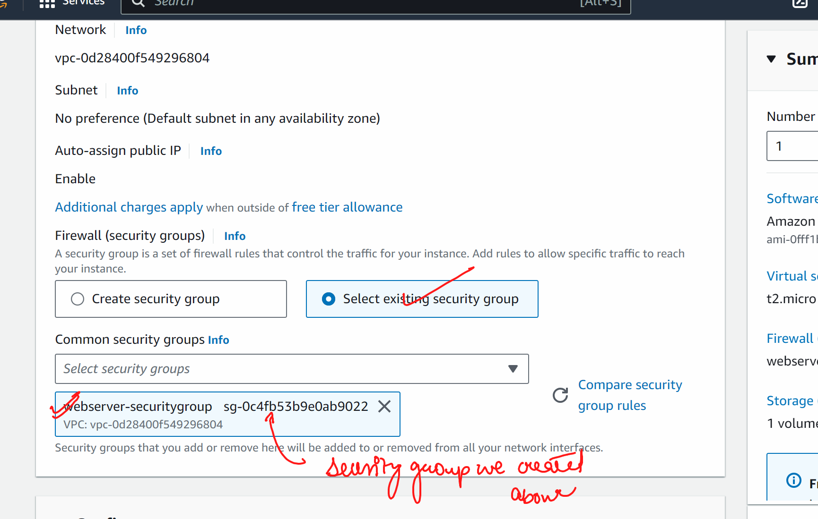

SCROLL DOWN

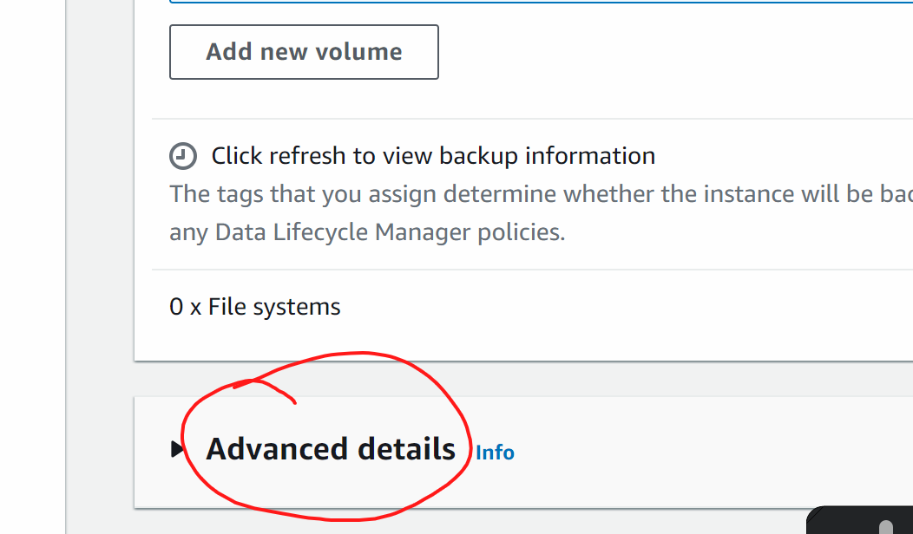

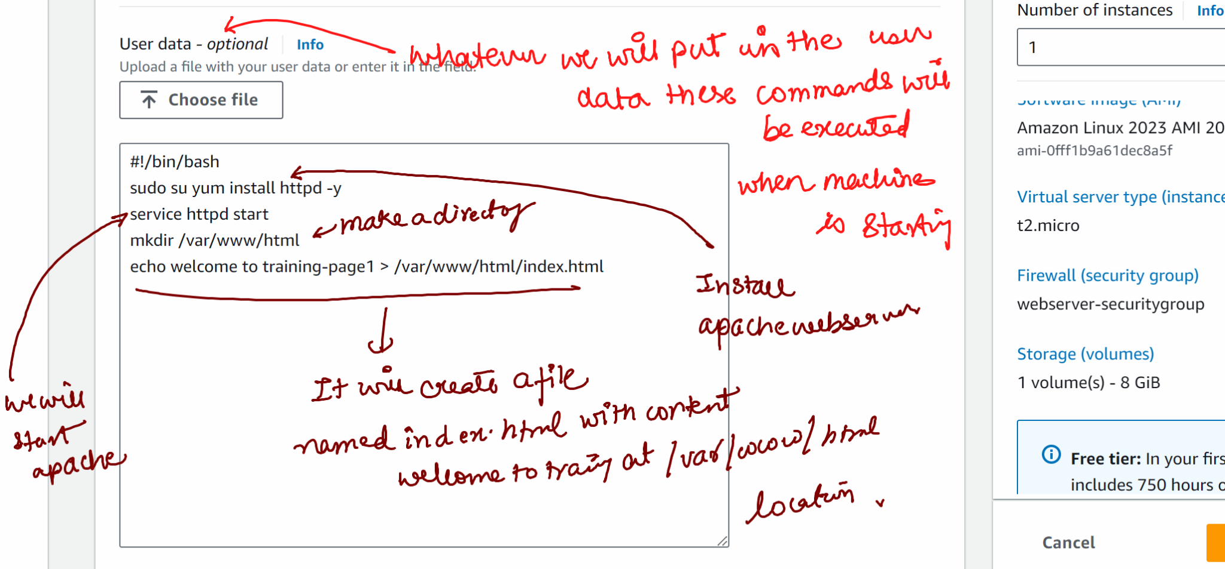

#!/bin/bash
sudo yum install httpd -y
service httpd start
mkdir /var/www/html
echo welcome to training-page1 > /var/www/html/index.html

Launch

### similarly lets launch other machine

Go to ec2 - launch ec2 instance

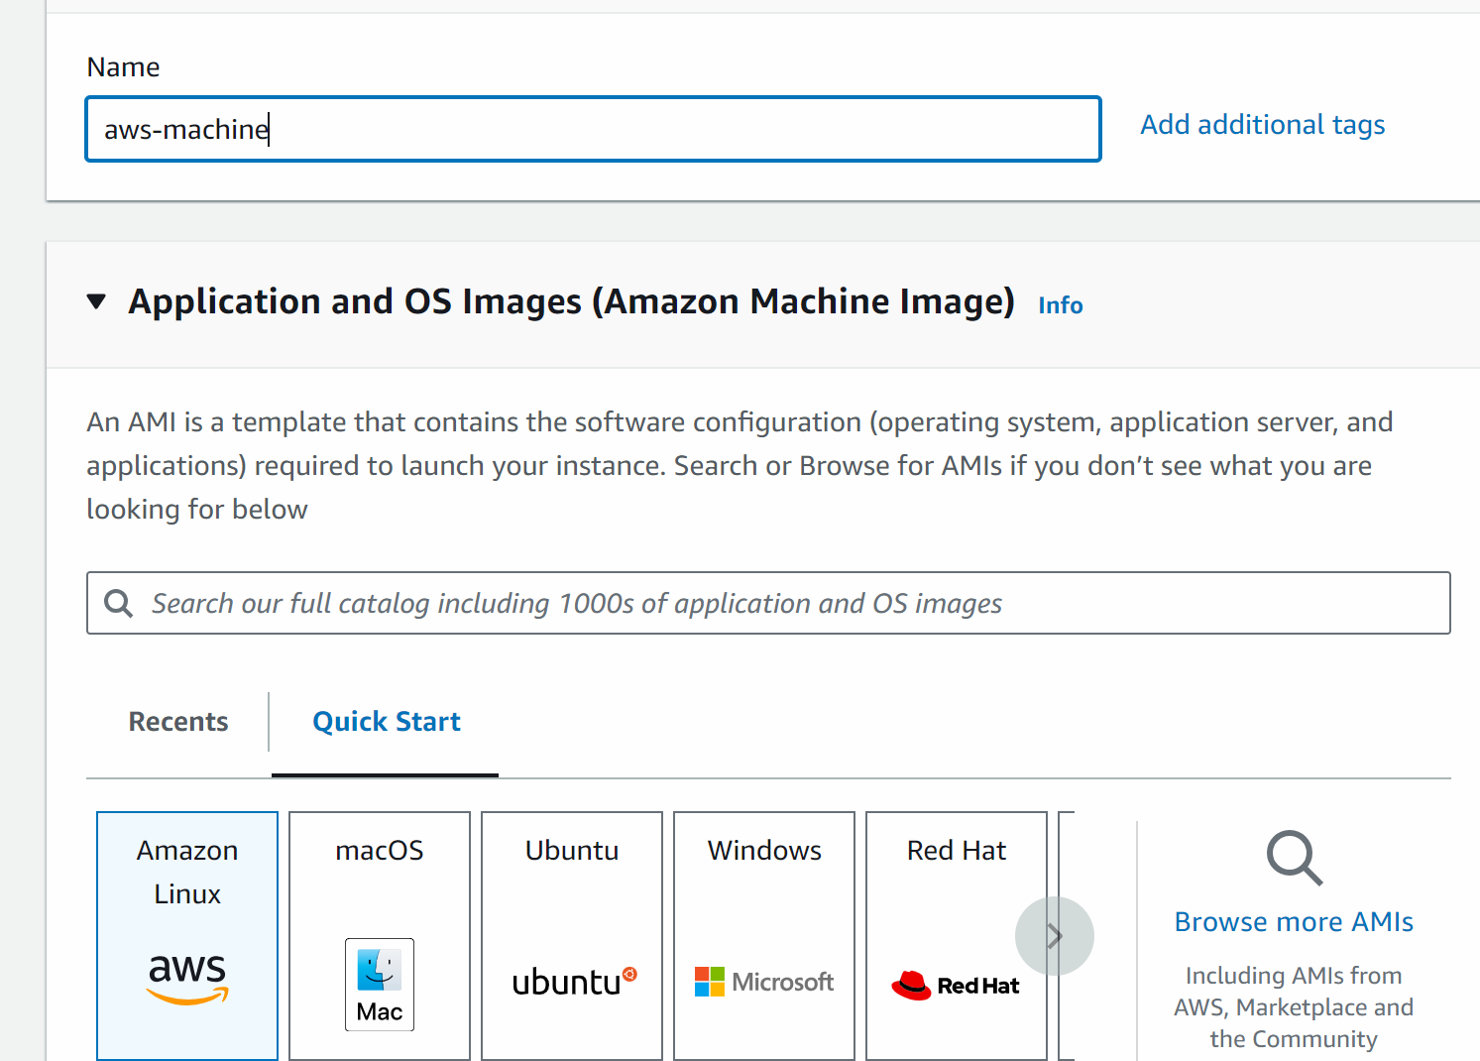

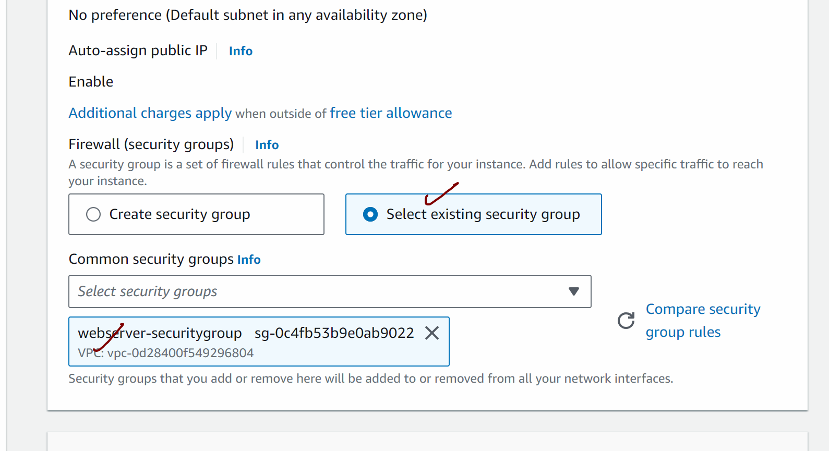

Scroll down and click on advanced details

#!/bin/bash
sudo yum install httpd -y
service httpd start
mkdir /var/www/html/aws
echo welcome to AWS training-page2 > /var/www/html/aws/index.html

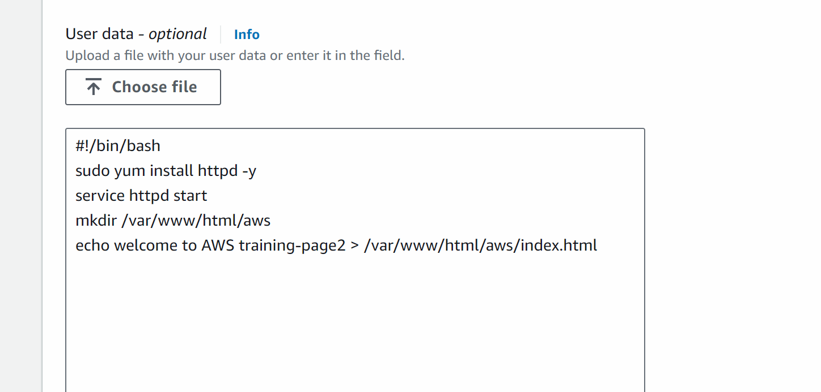

Launch instance

#####

We will create one more machine which would be ec2 machine with a different path

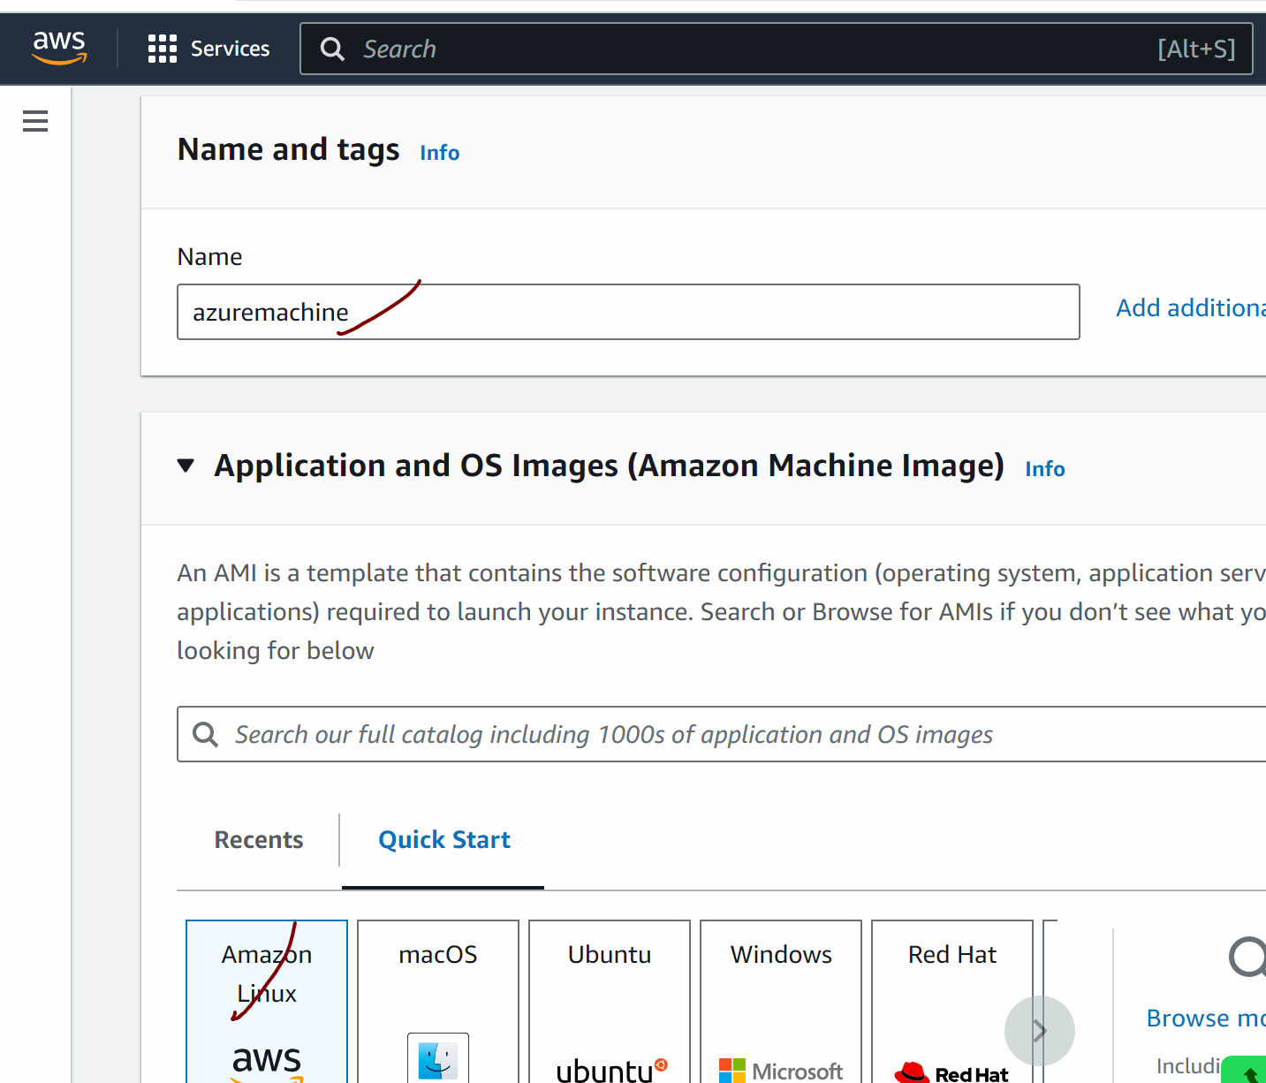

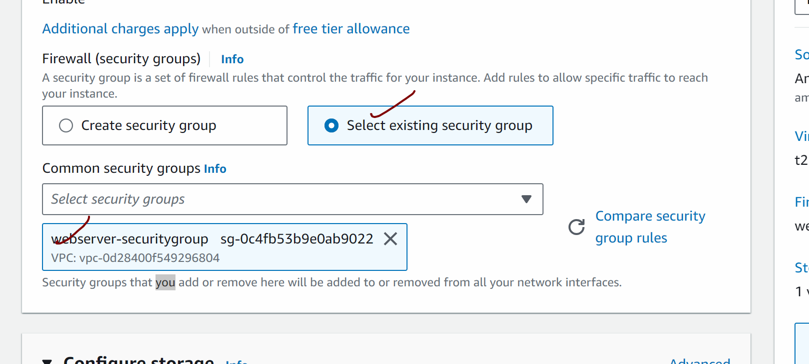

Click on advanced details

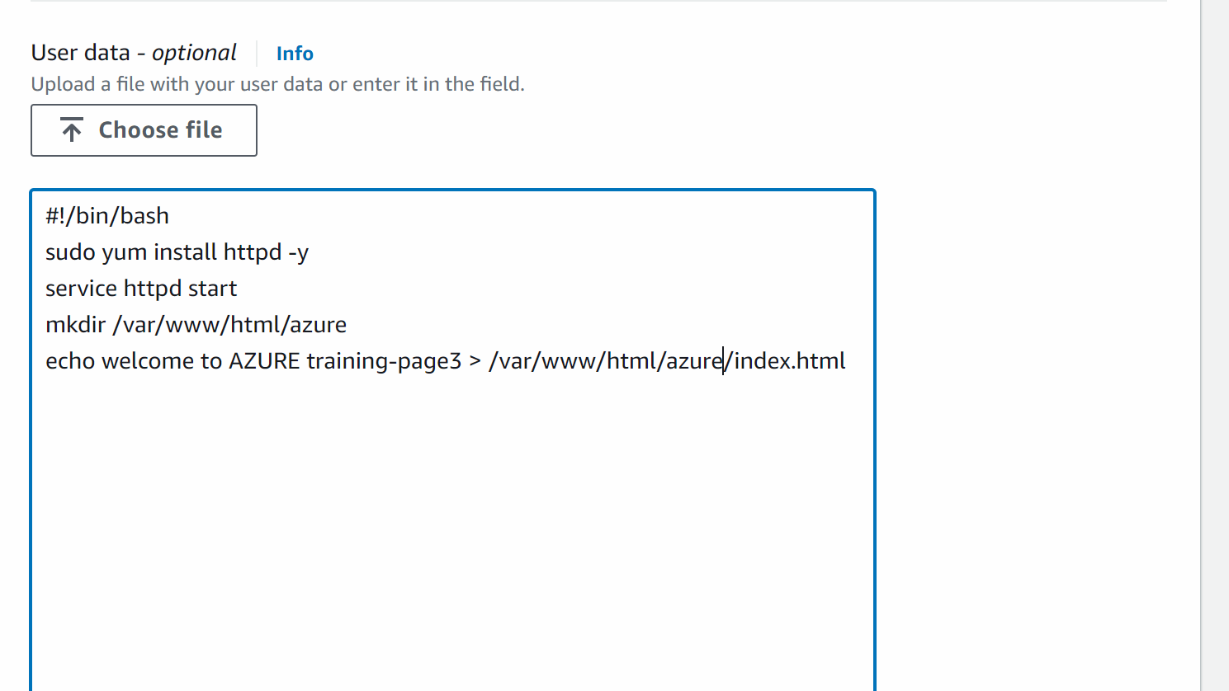

#!/bin/bash
sudo yum install httpd -y
service httpd start
mkdir /var/www/html/azure
echo welcome to AZURE training-page3 > /var/www/html/azure/index.html

Launch instance

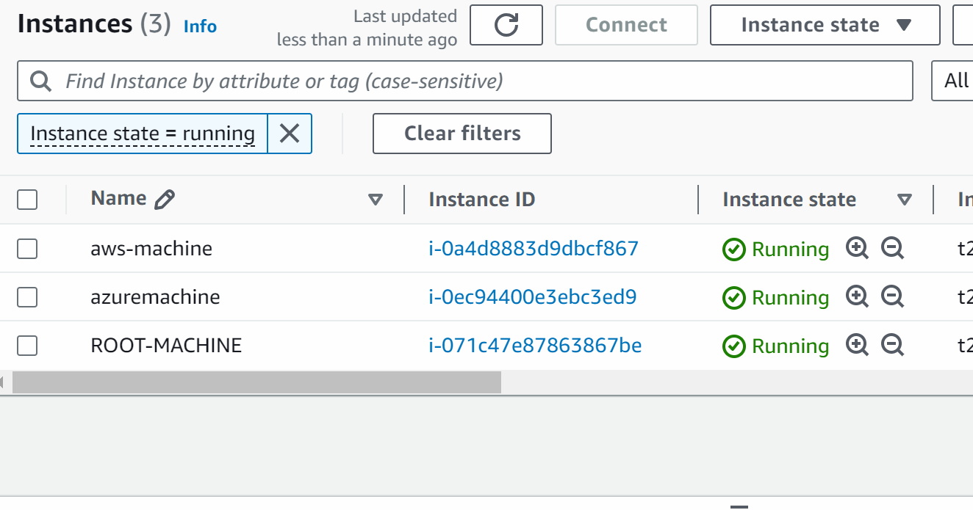

############################

WE WILL NOW CREATE THiE LOAD BALANCER

BEFORE THAT FIRST WE SHOULD CREATE THE TARGET GROUP….LIKE WHICH MACHINES TO BE TARGETTED BY LOAD BALANCER

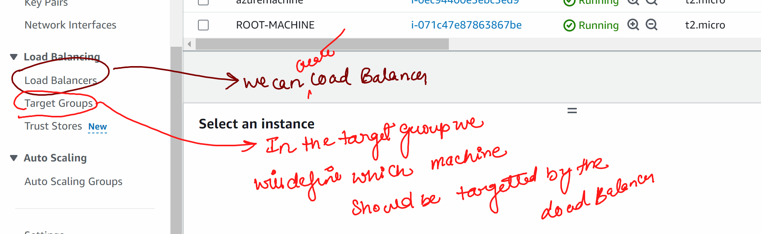

TARGET TYPE : INSTANCES

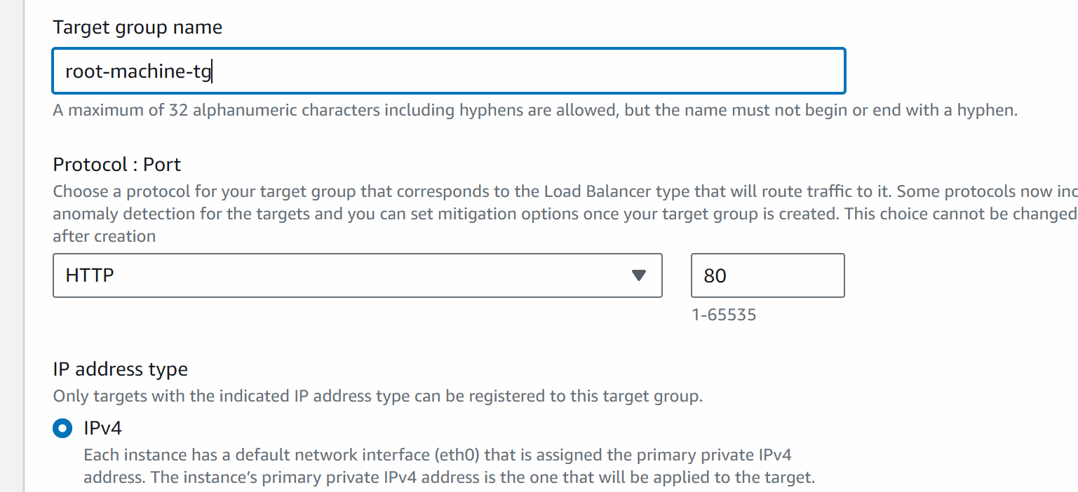

Next

Select root machine -> include as pending below

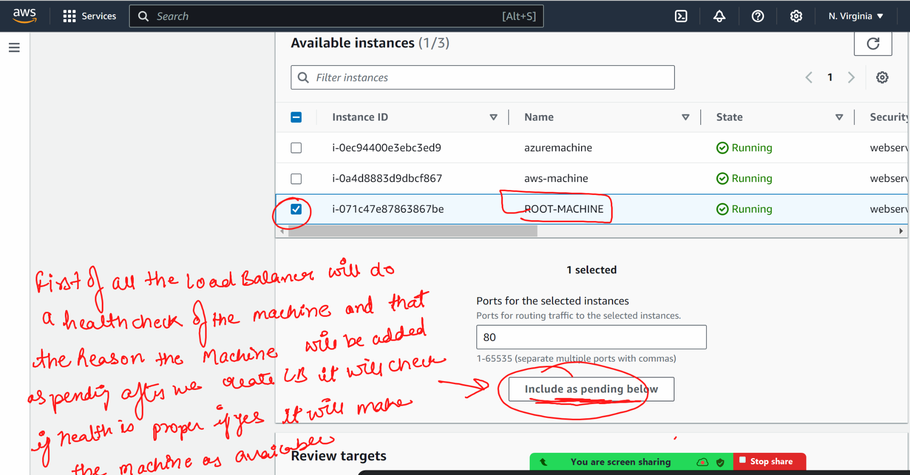

Create a target group

NOW WE WILL CREATE ANOTHER TARGET GROUP FOR /AWS
Go to target group -> create target group

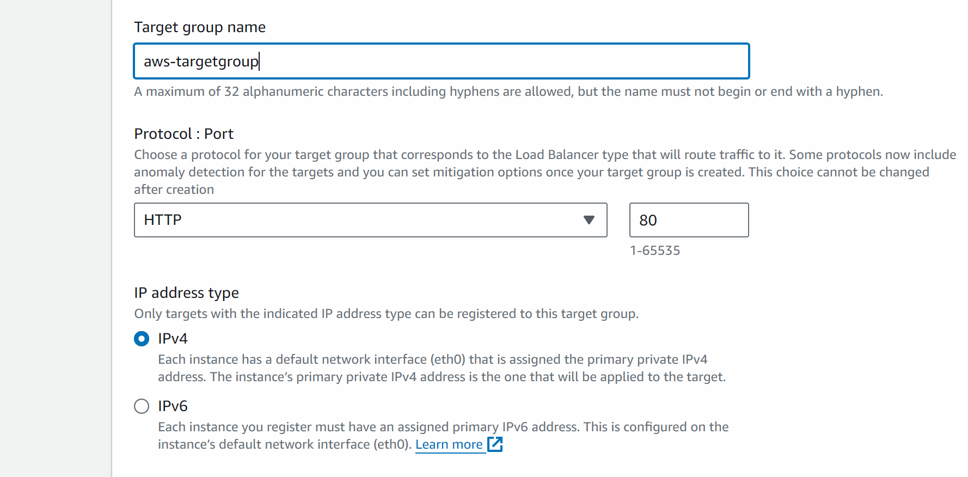

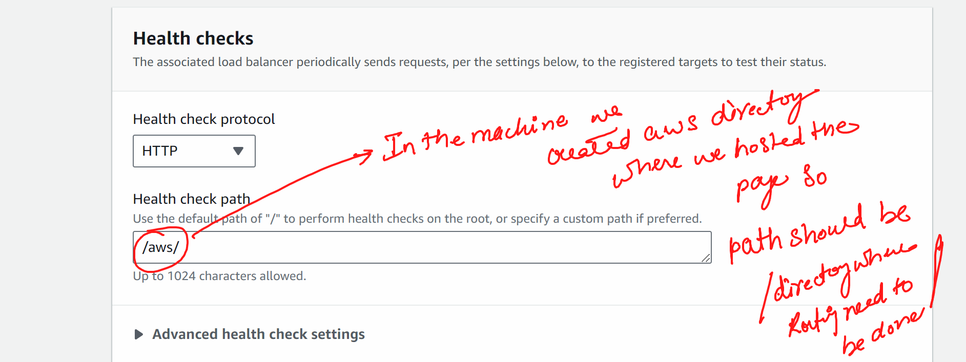

Next

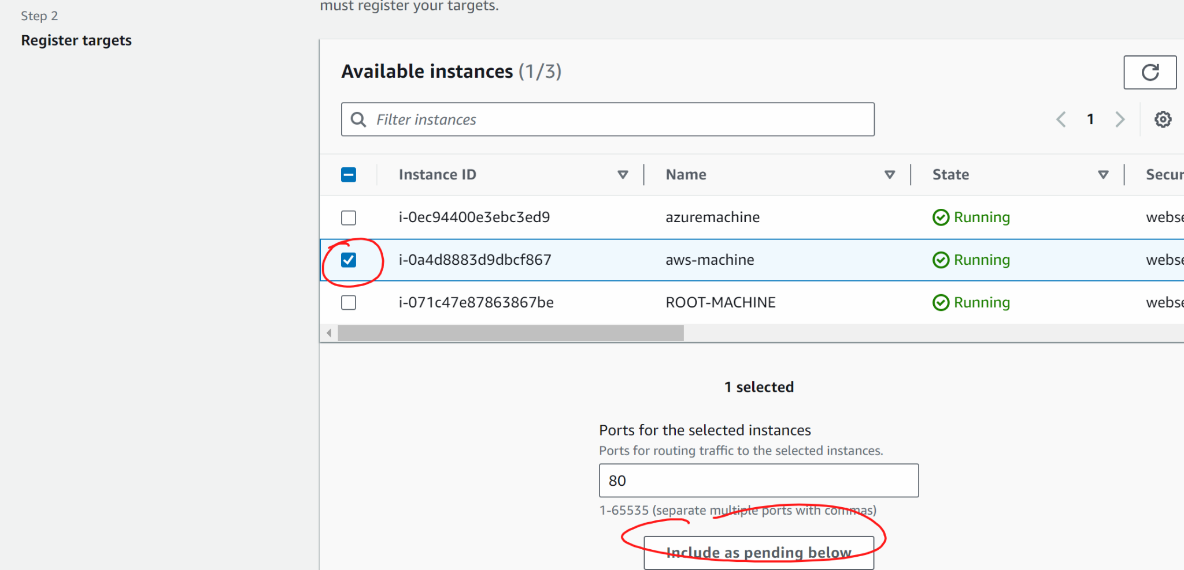

Create target group

### NOW WE WILL CREATE THIRD TARGET GROUP

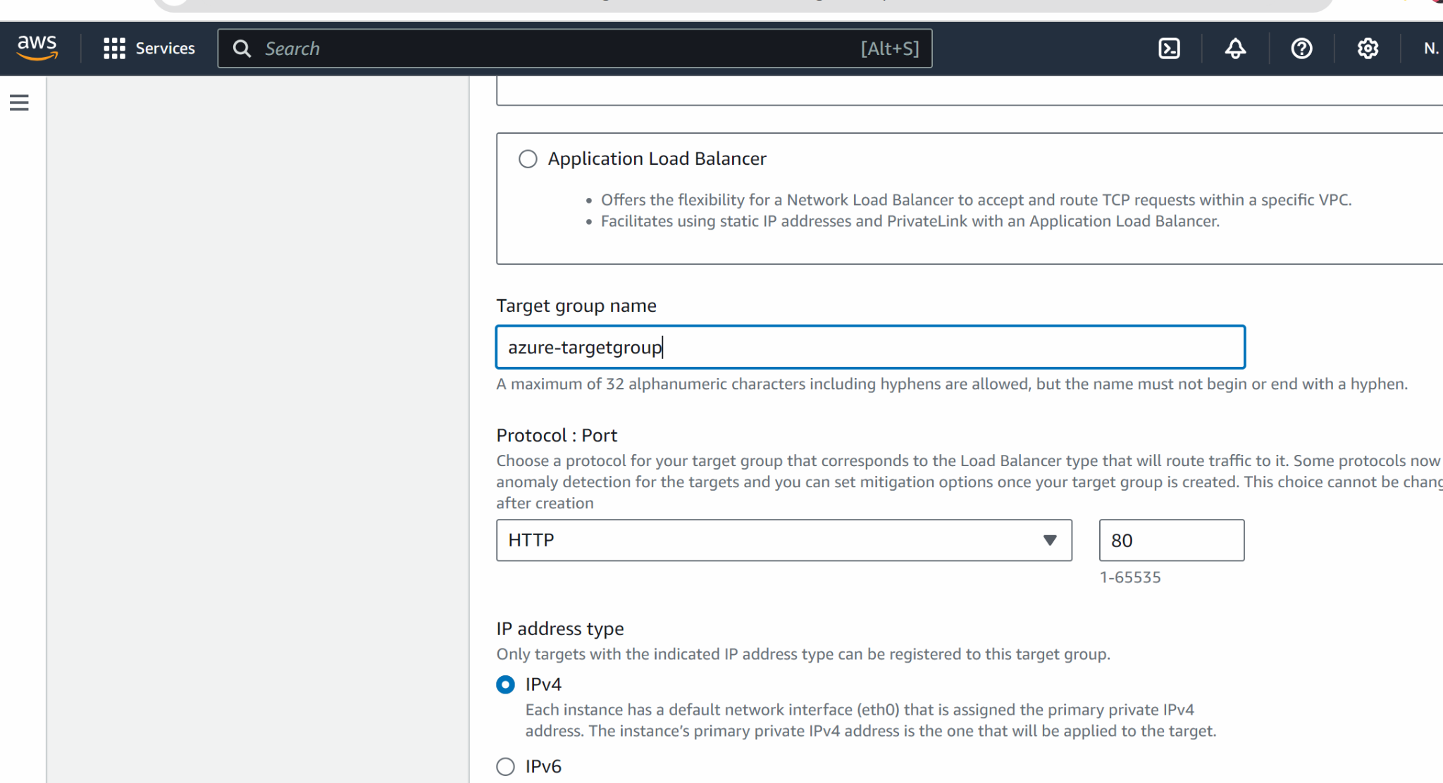

In health check we will put /azure/
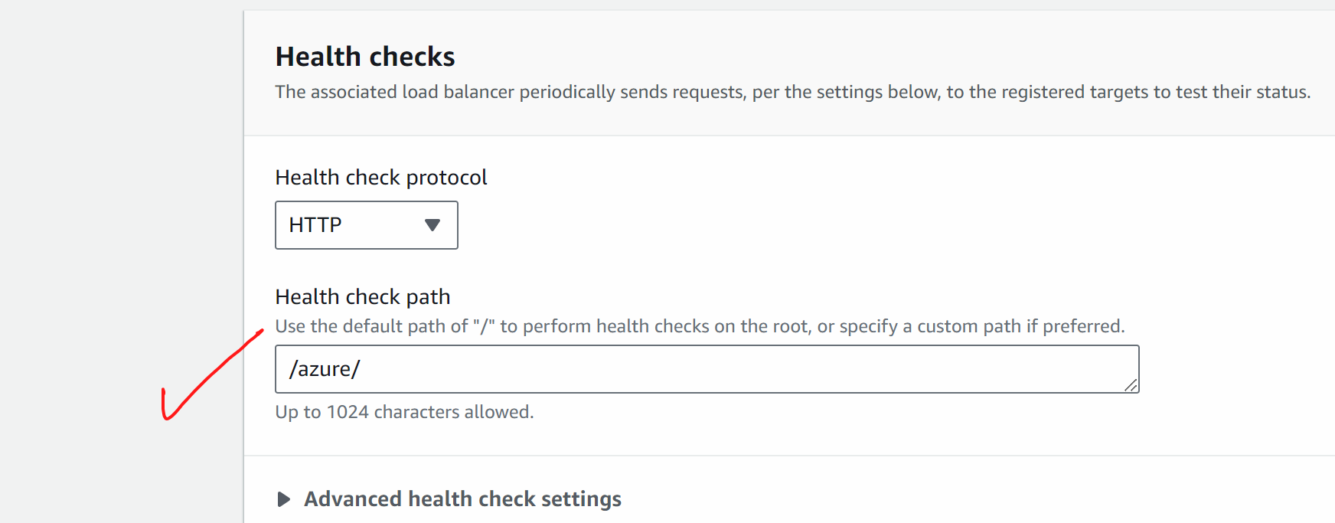

Next

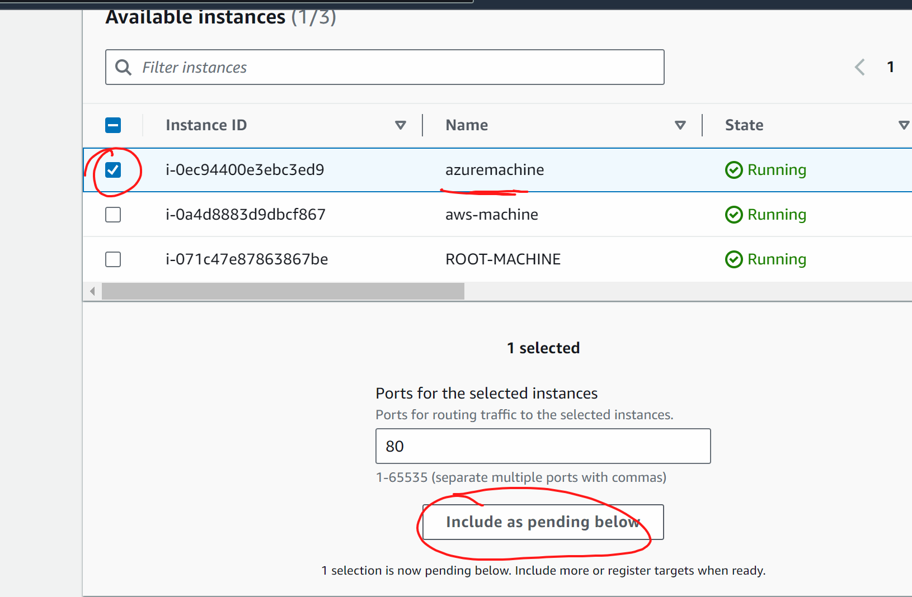

Create target group

########

We will now create a load balancer

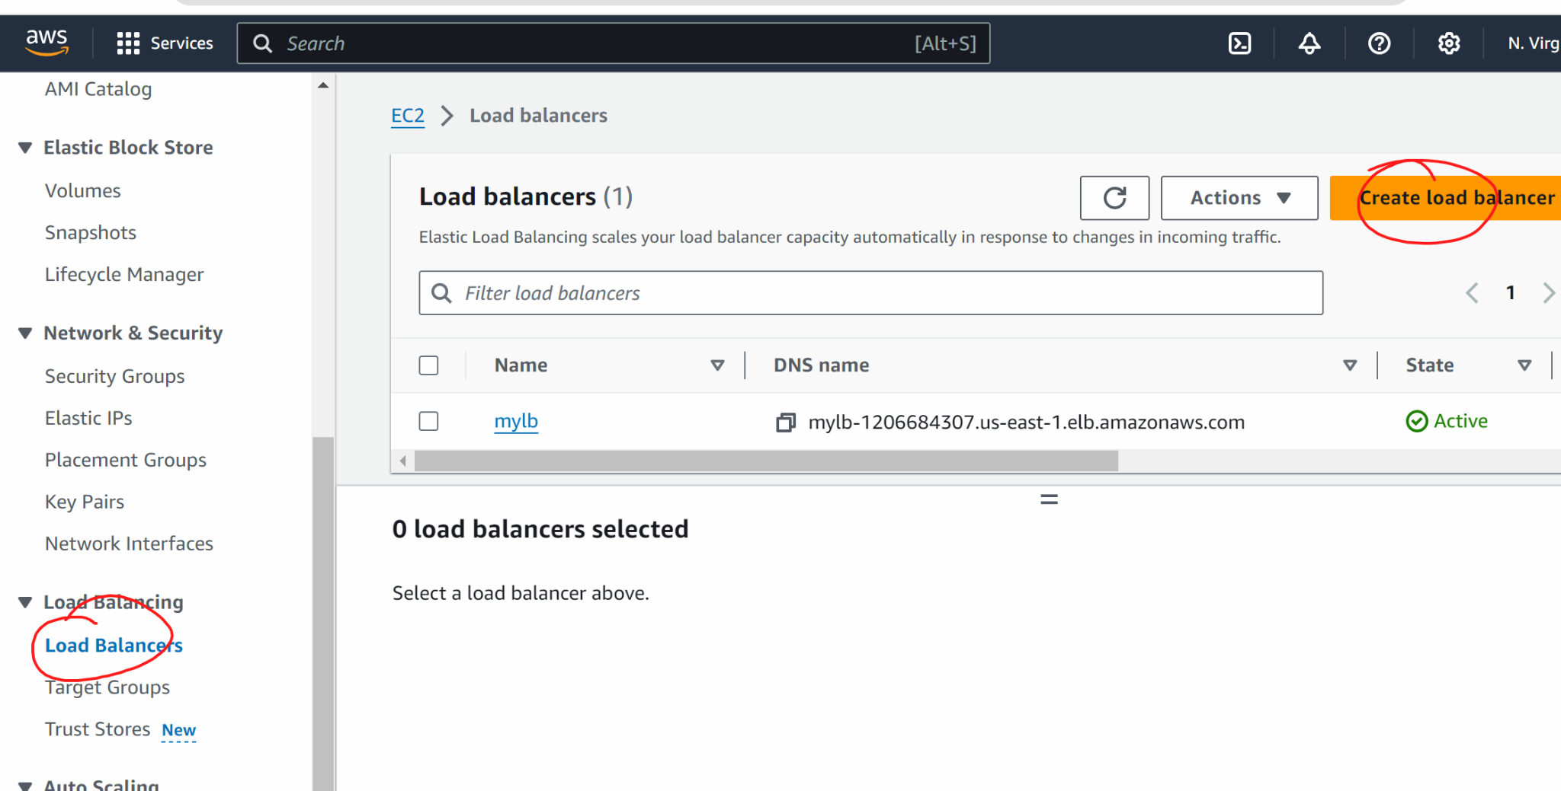

Select application load baalncer

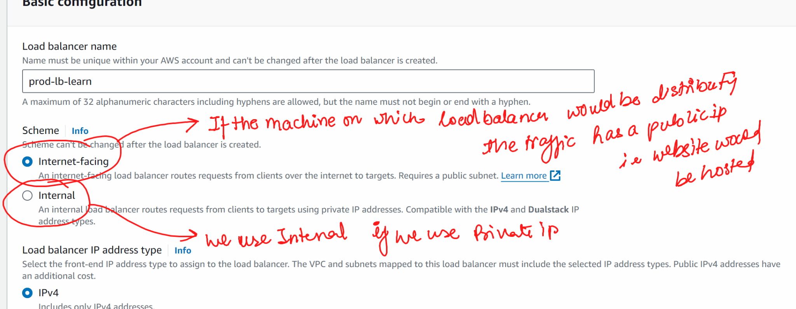

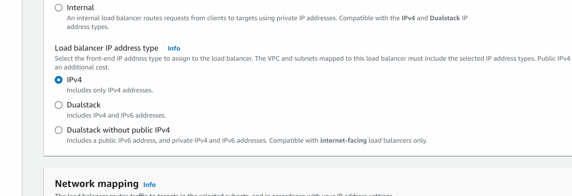

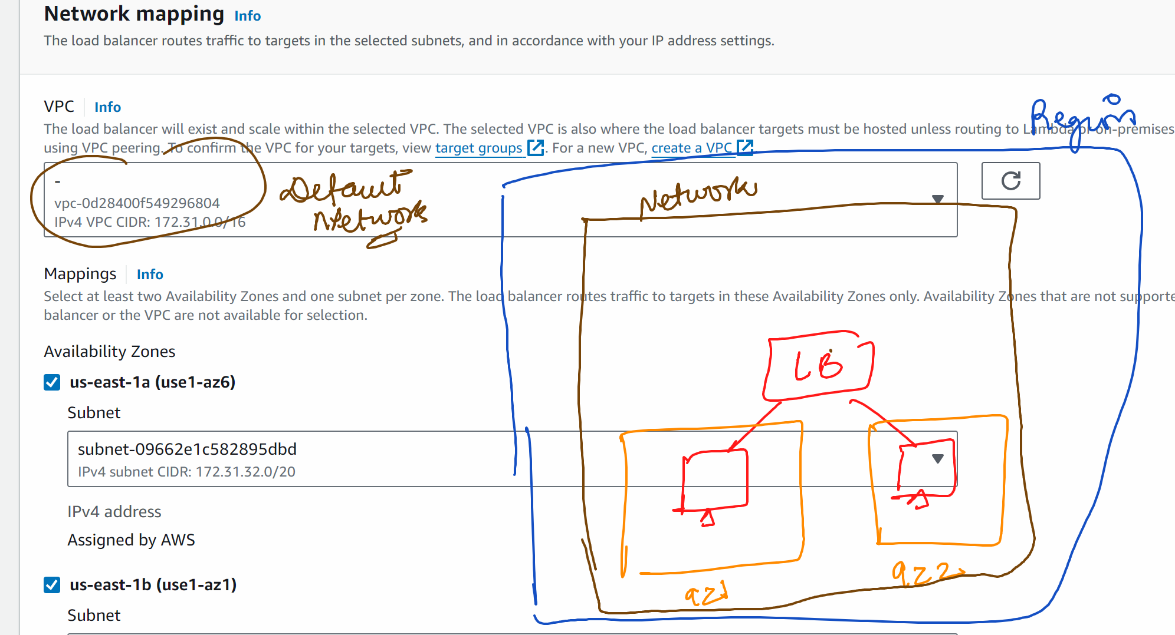

Select all availability zones

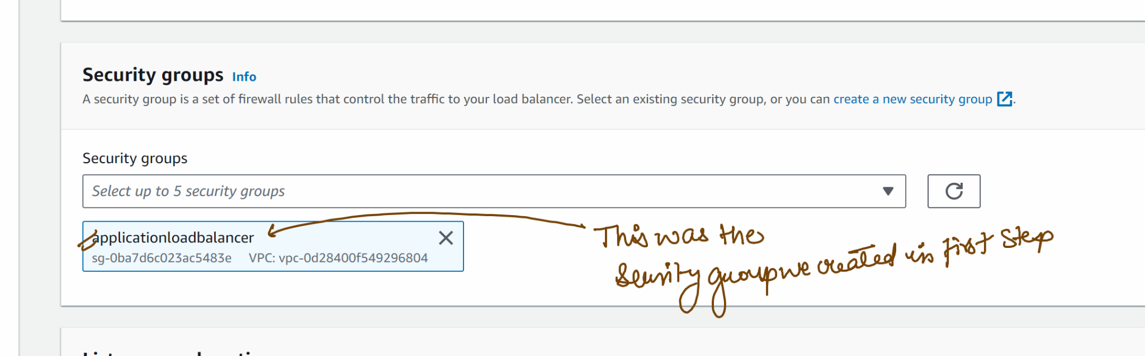

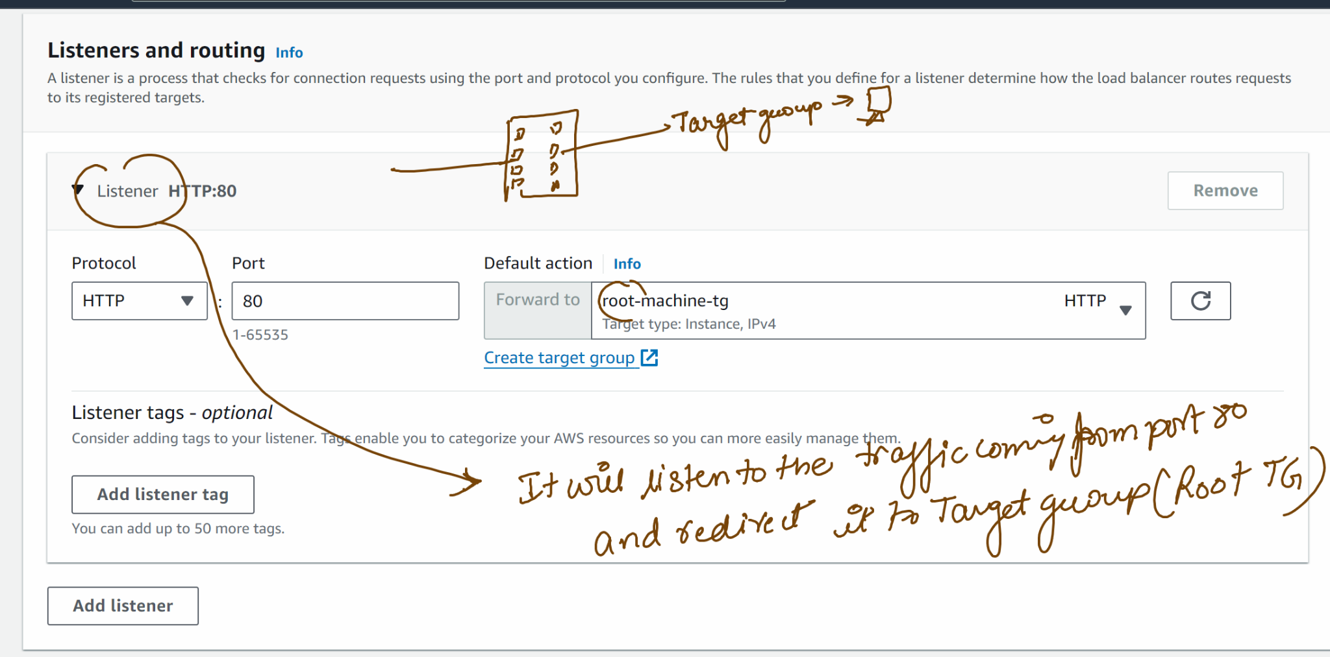

Create a load balancer

Wait for the load balancer to launch

Check if the target is healthy….go to target group …click on the target

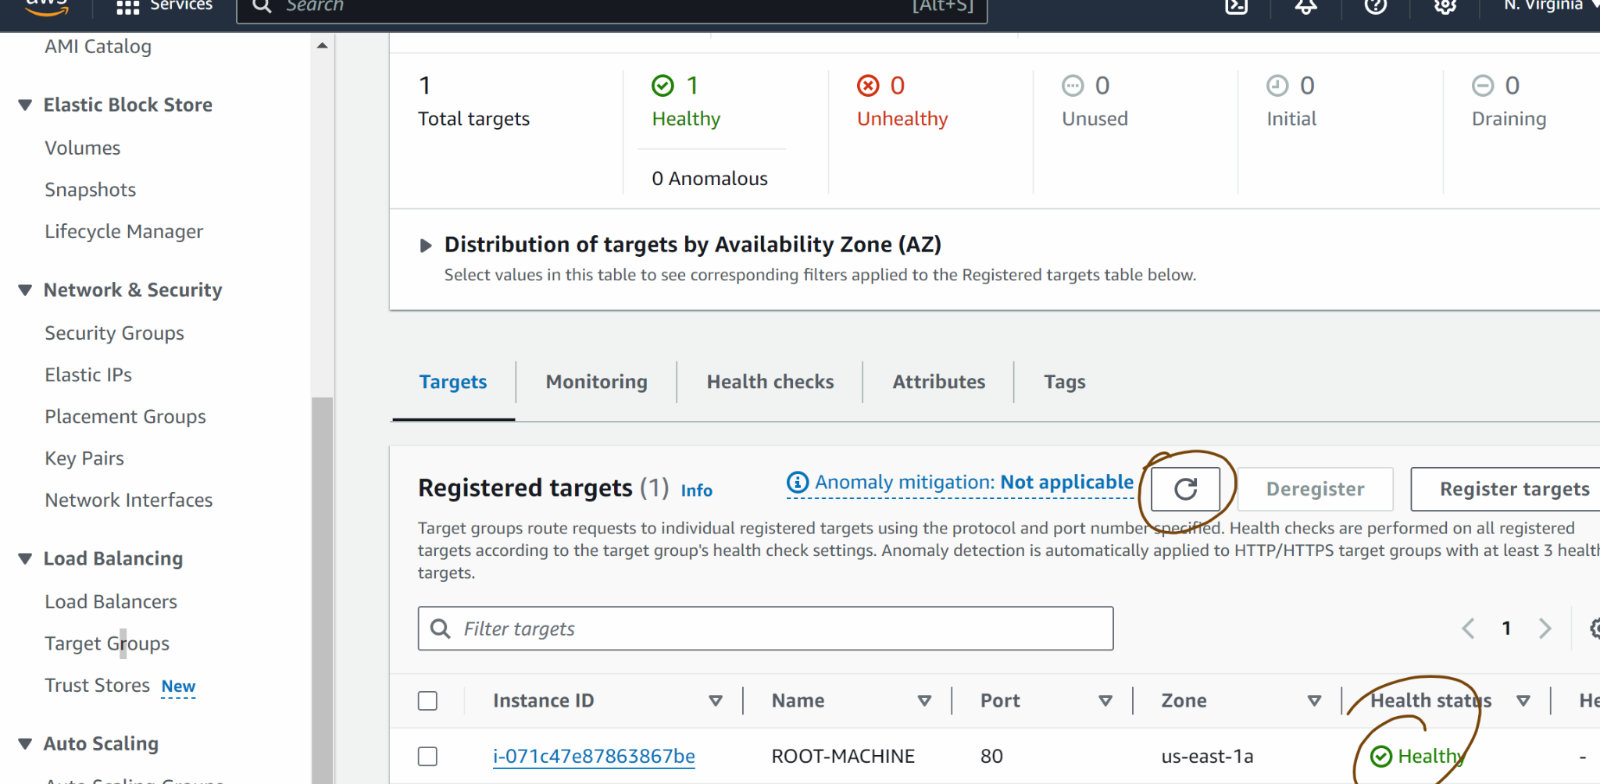

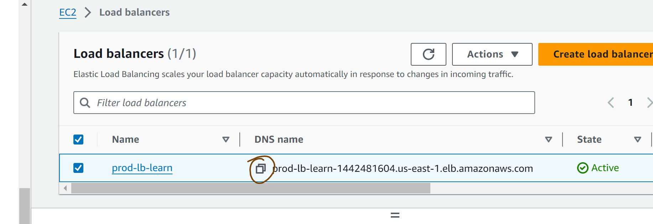

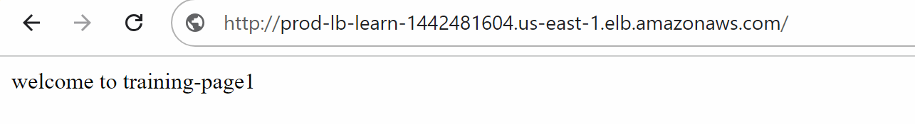

Click on the load balancer

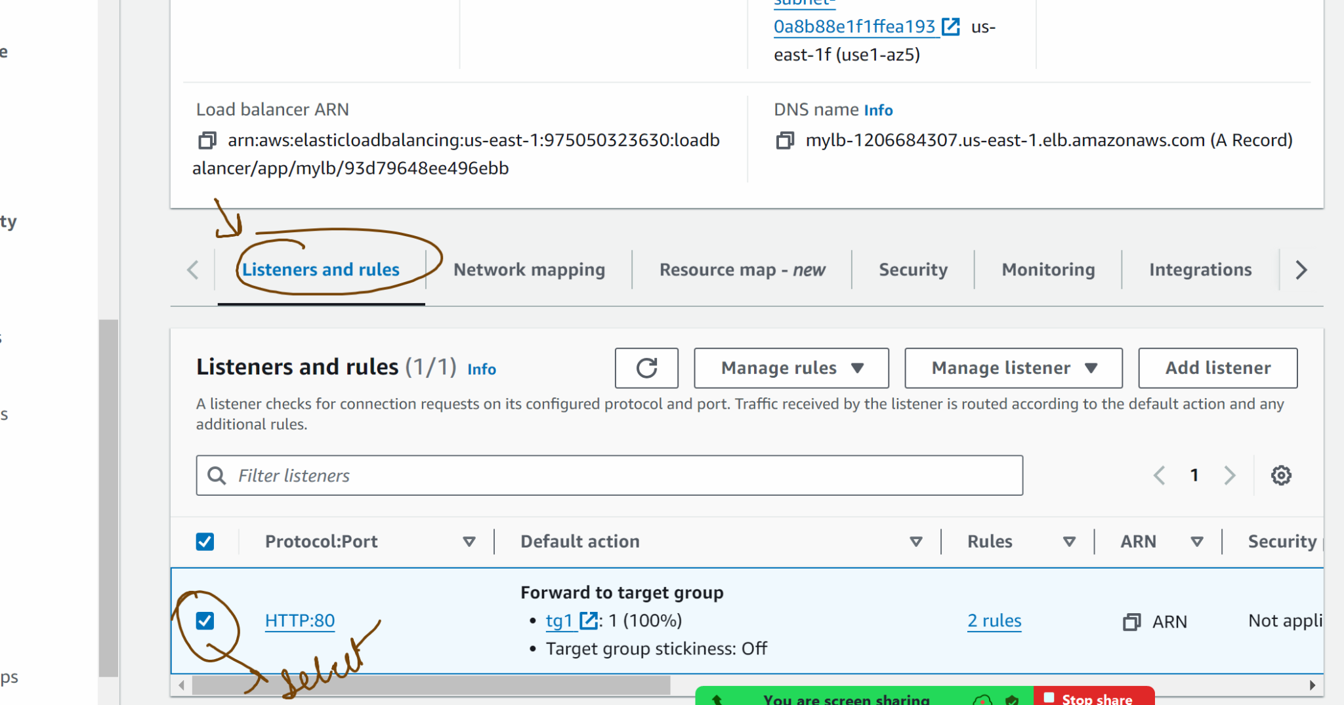

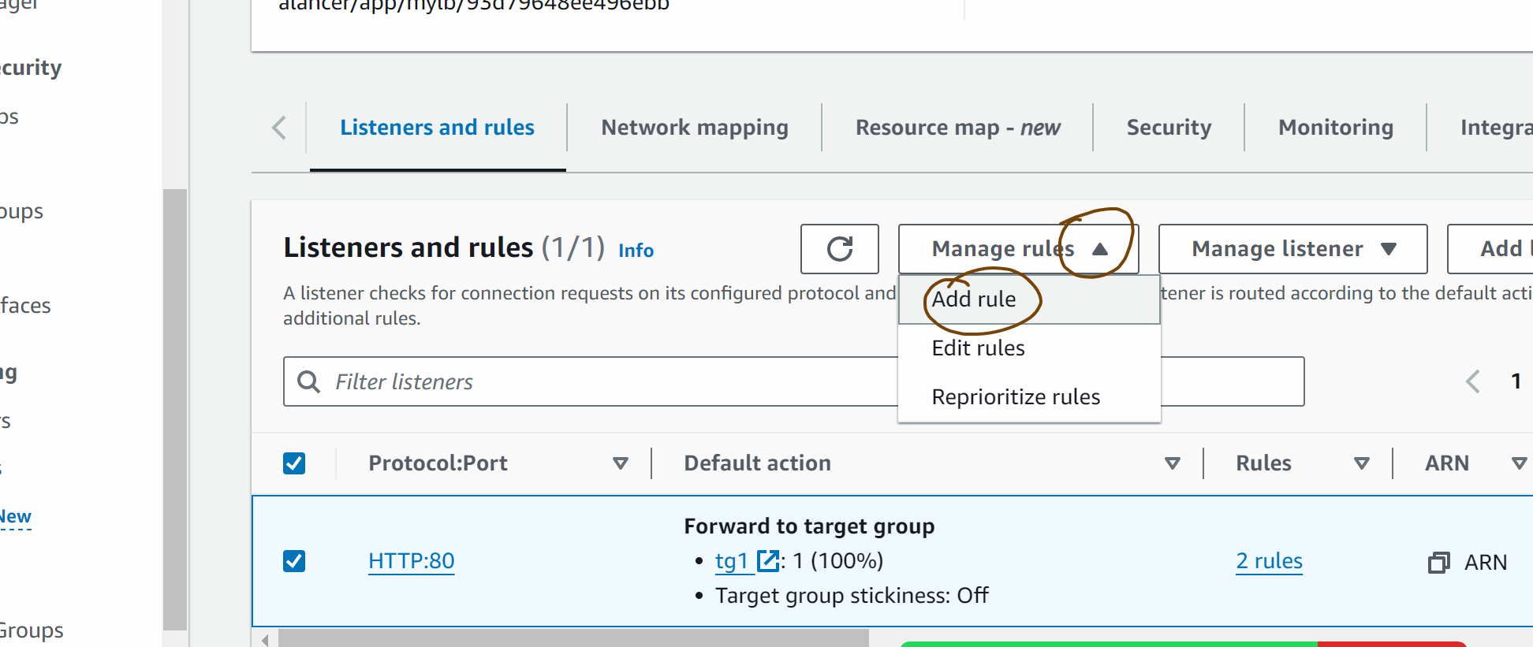

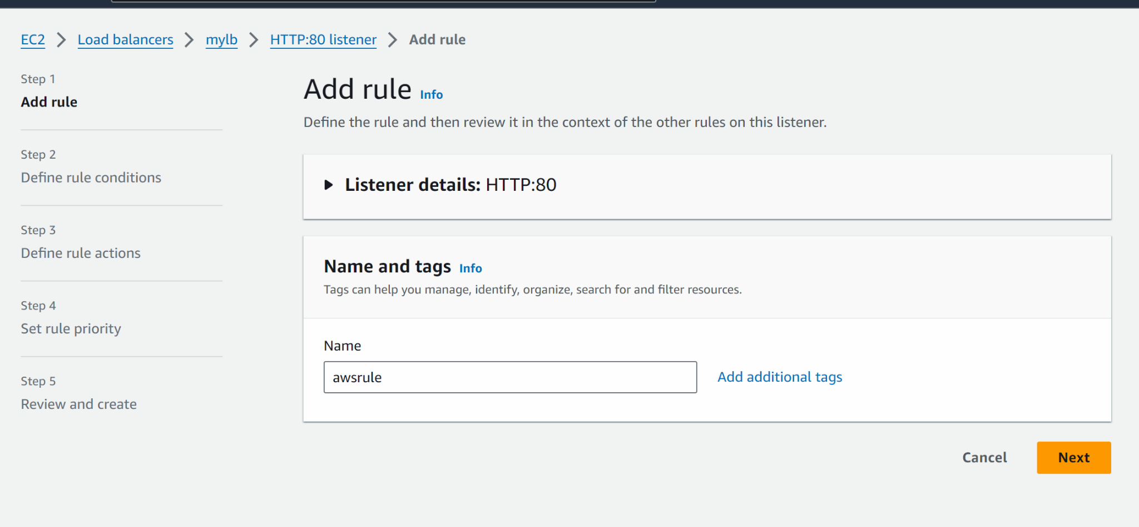
next
Add condition
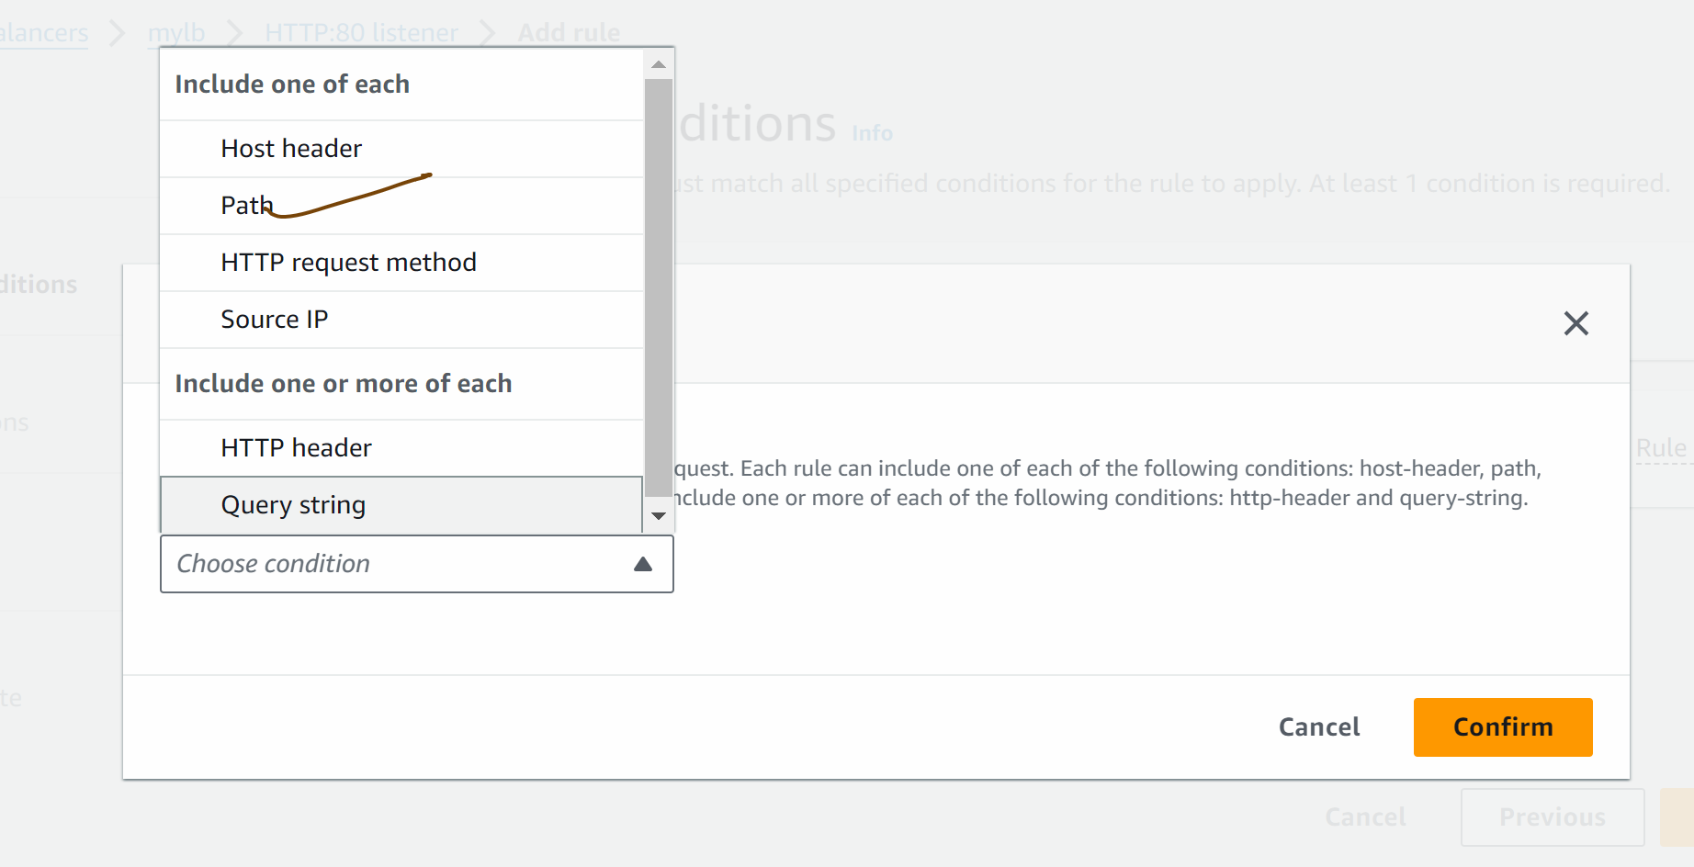

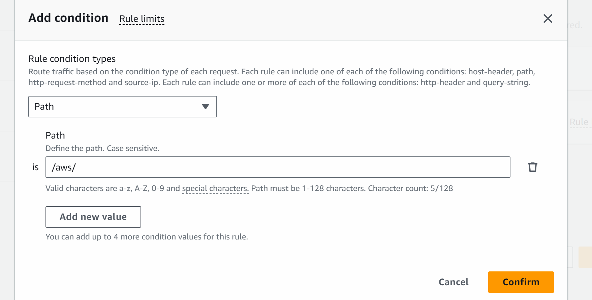

Confirm

Next

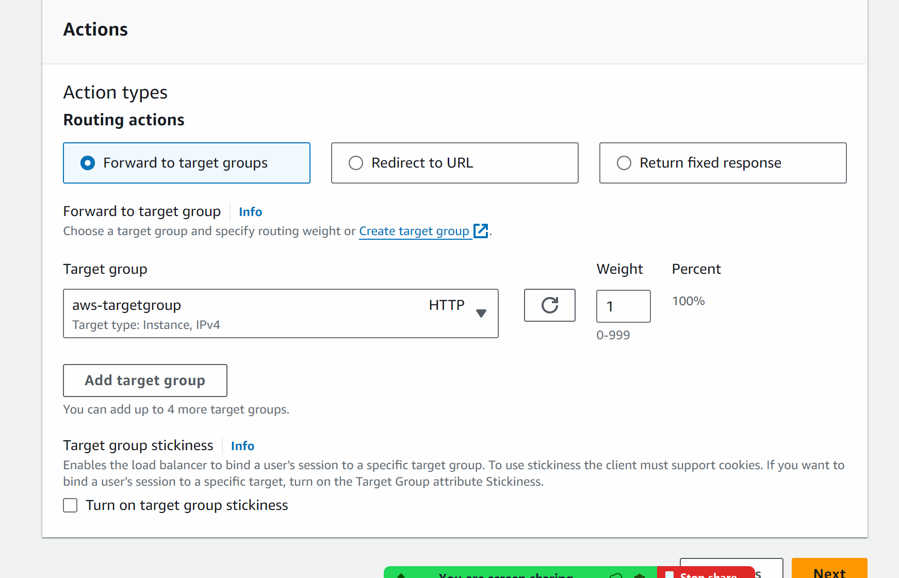

Next

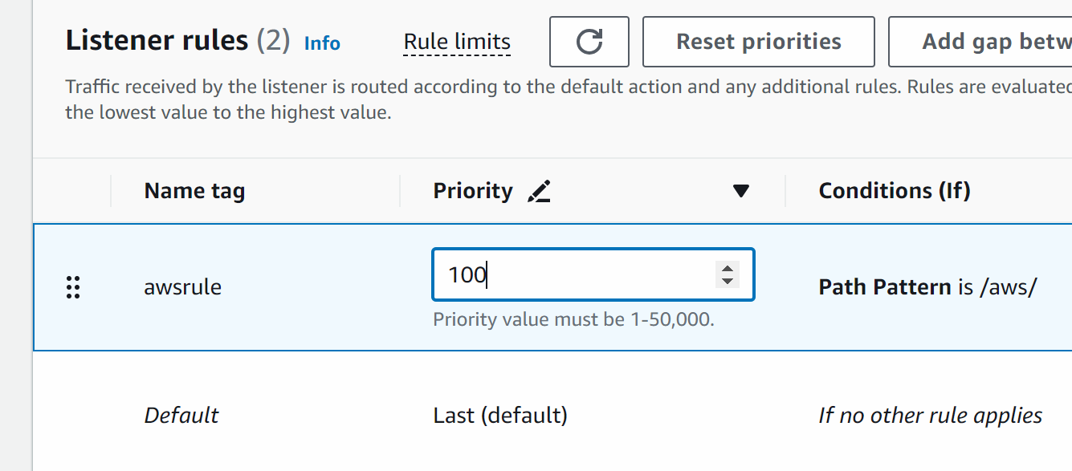

Create

Lets create the rule for azure page as well

Go to load balancer click on load balancer …scroll down

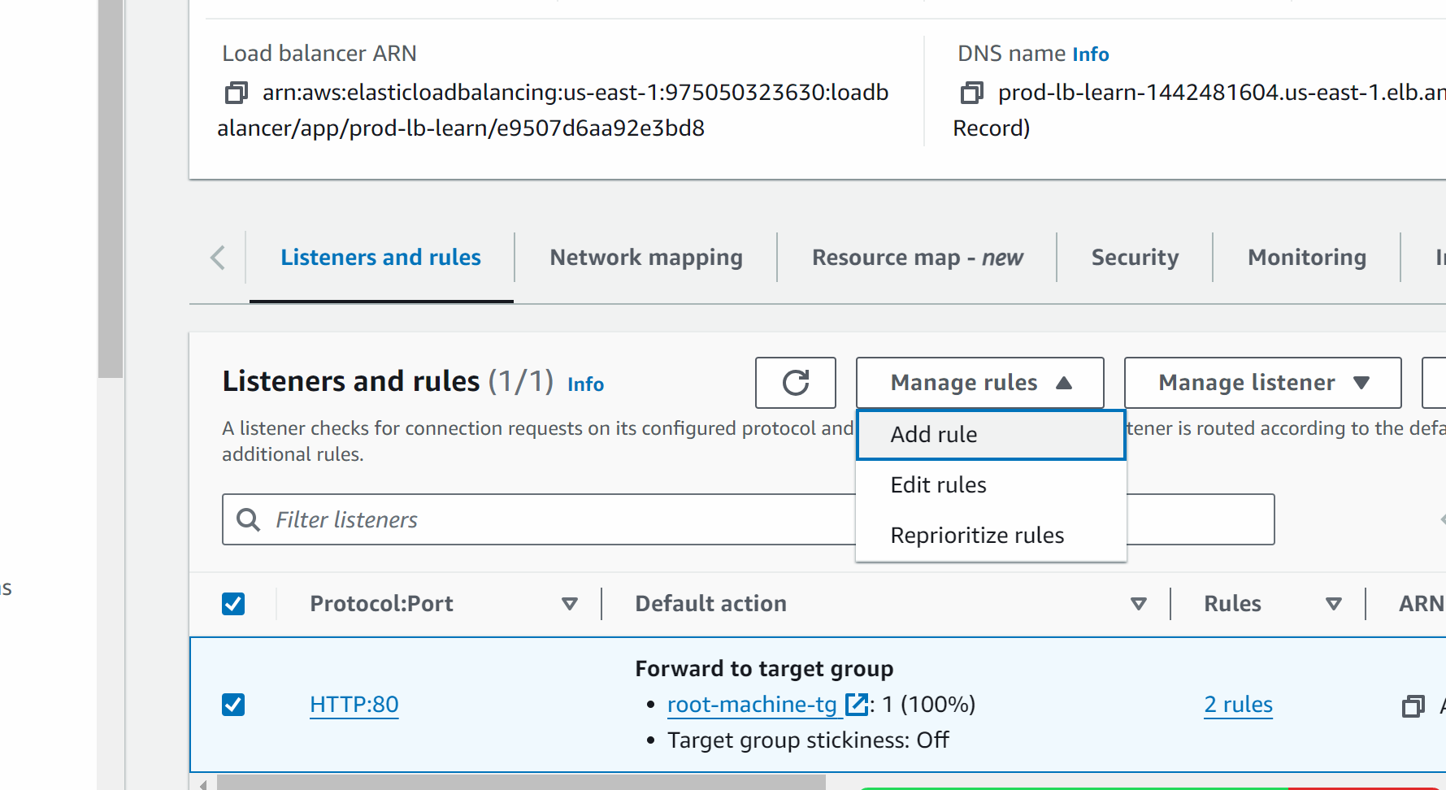

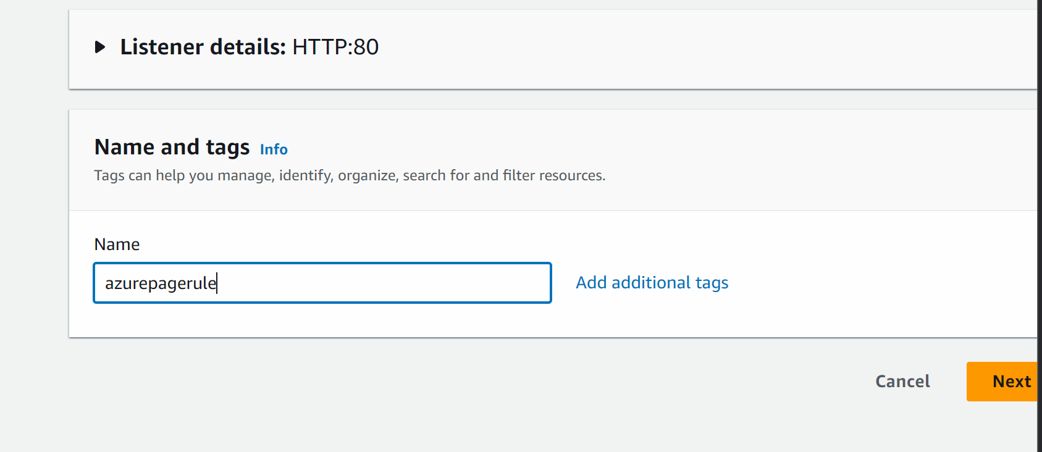
Next
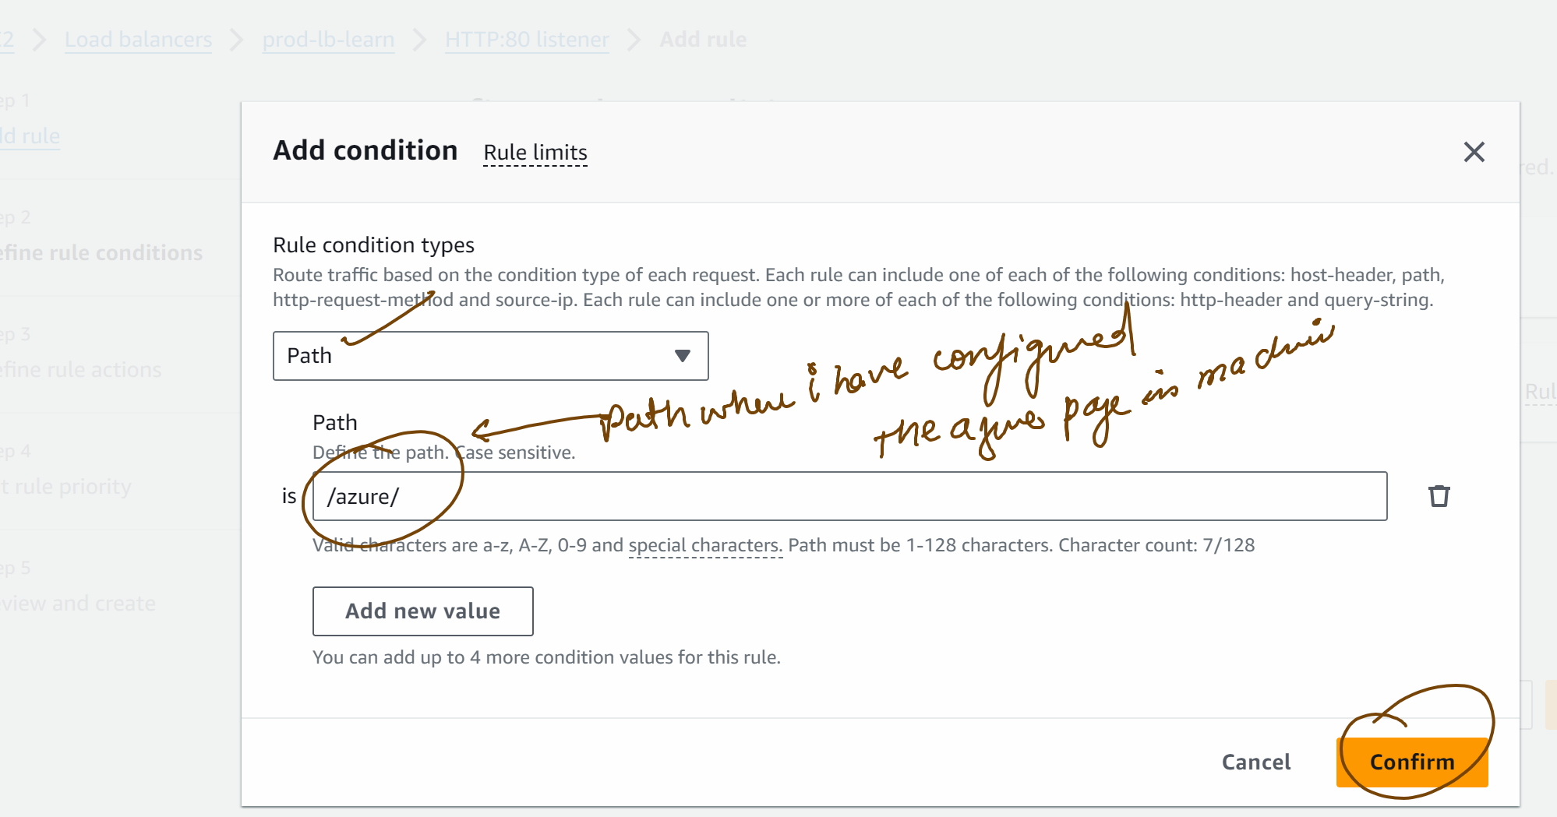

Next

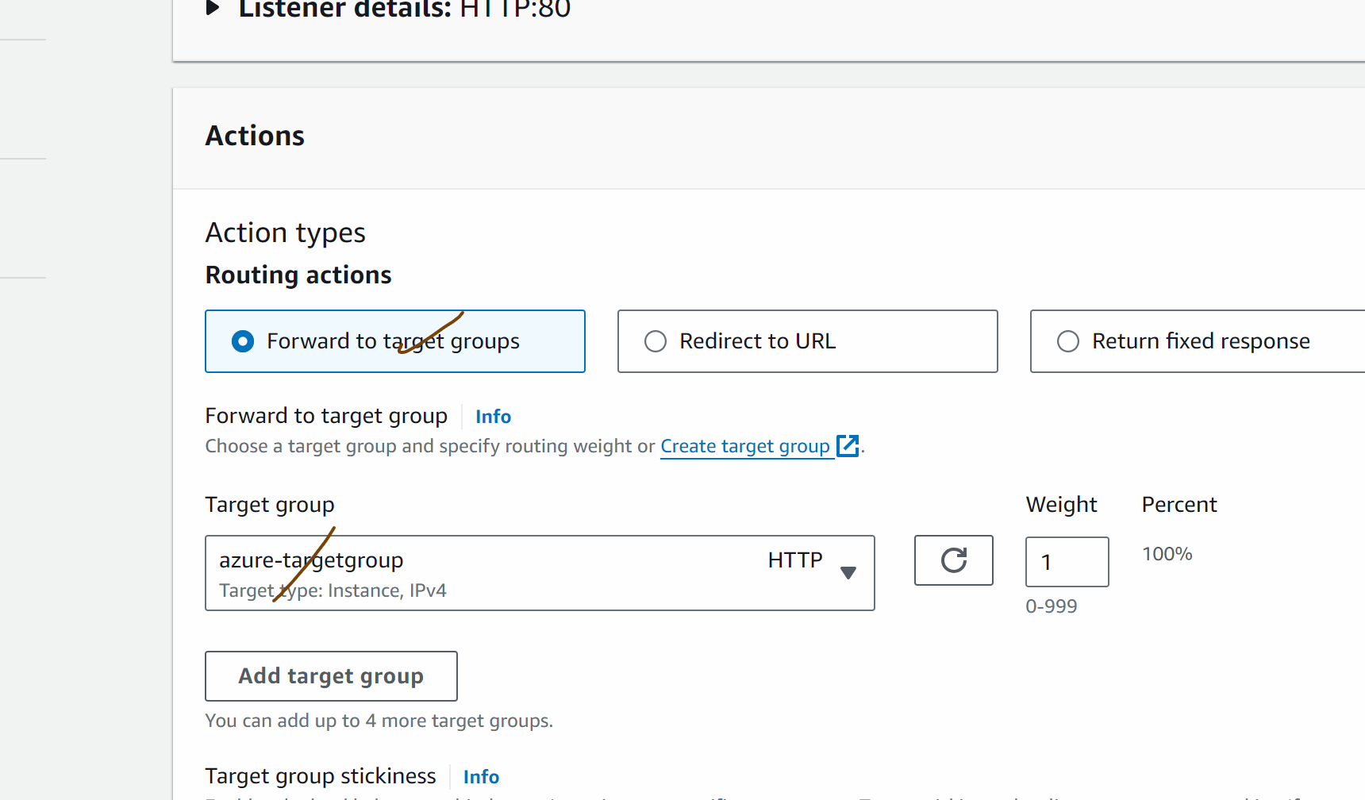

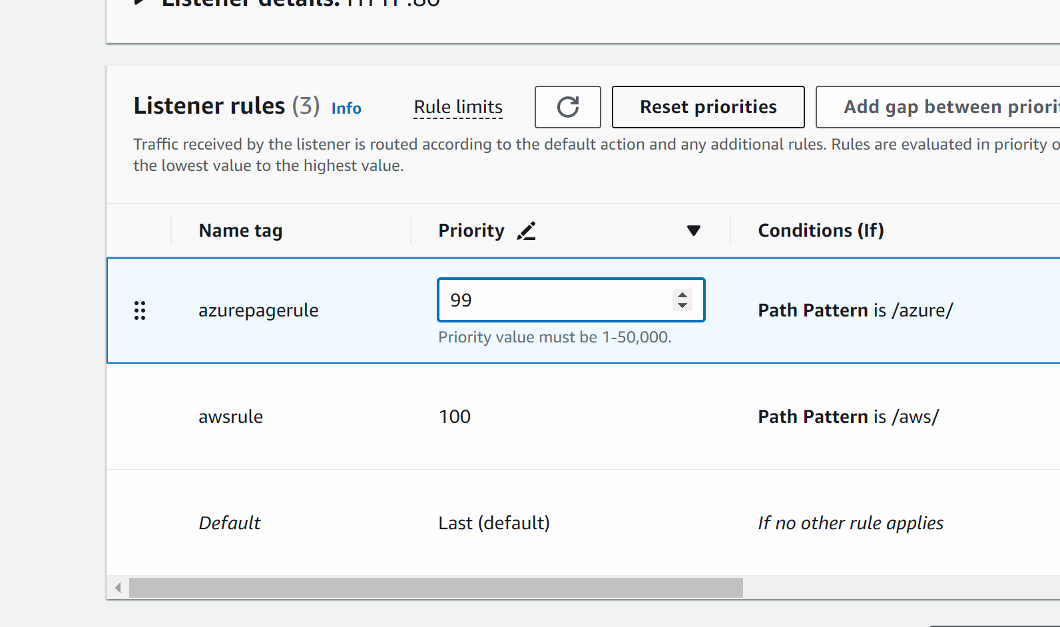

Next
Create

Go to load balancer and copy the dns…open in the new tab

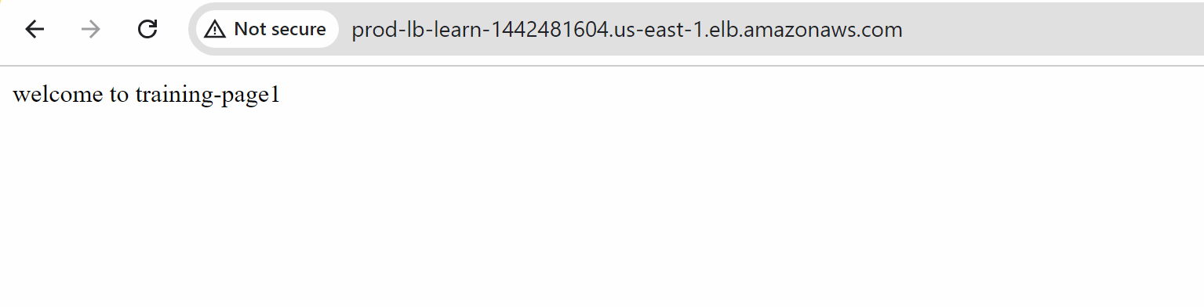

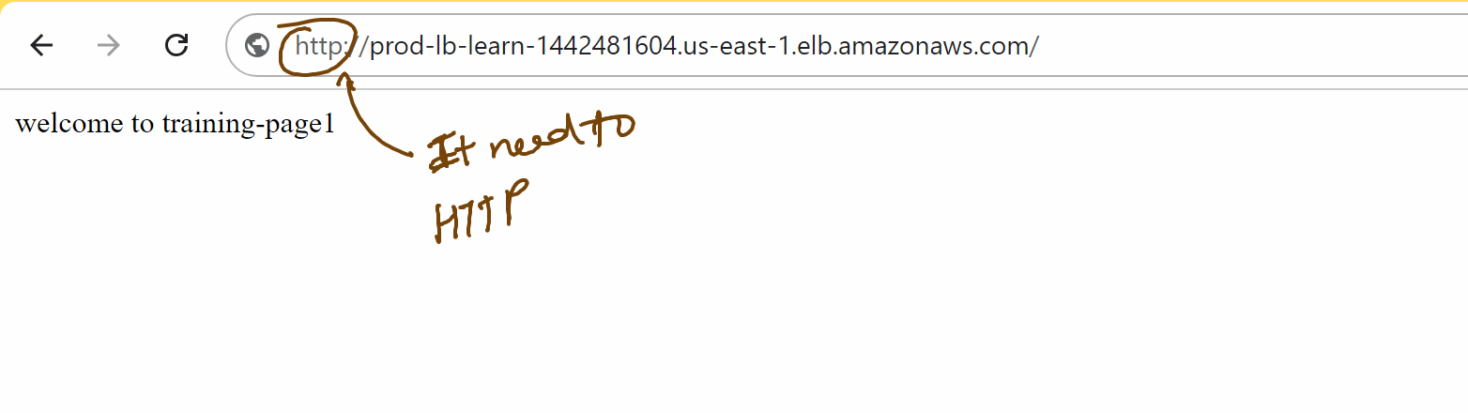

lbendpoint/aws

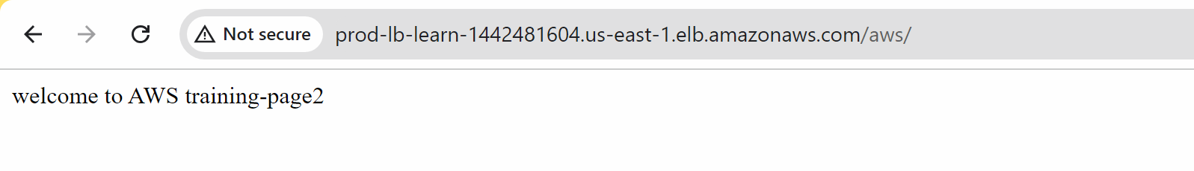

lbendpoint/azure

